United States Coast Guard Auxiliary Honor Guard
Four Person Flag Fold Protocols
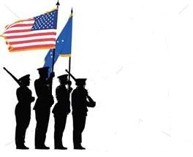
Positions:
Presenter (Head of the detail at the canton, (blue field))
Folder (Opposite End, primarily folding the flag)
Side Attendants (2) (Assist in holding the flag taunt and horizontal)
Steps:
- Assign positions.
- Assemble in position.
- Commence on the Presenter command, “begin”.
- Presenter remains stationary.
- The folder and the side attendants move quietly while folding the flag.
- Side Attendants keep the flag taunt and horizontal
- When the flag is in the final tuck position, only the folder and presenter work to tuck and shape the flag.
- Side Attendants at this time will come to attention.
- When the flag is tucked and shaped it will be placed into the right palm of the presenter with the presenter than placing his left hand on top of the flag. The flag point will be towards the presenter. See picture:

- The folder will now come to attention and issue the command, “present arms”.
- The presenter and side attendants will render a slow 21 count ceremonial salute, (7 seconds up, and then hold 7 seconds).
- After holding for 7 seconds the folder will issue the command, “order arms” at which time the presenter and side attendants will return their salute hand to the attention position in a 7 second descent.
- The presenter will then make a left or right face turn and march to the PNOK.
- Here he will kneel (with his knee never touching the ground) or bend at the waist, make eye contact and make the following statement: (On behalf of the President of the United States and the United States Coast Guard family and a grateful Nation, please accept this flag as a symbol of appreciation for your loved ones faithful service to our Country.)
- At this point the flag is presented to the PNOK and the presenter rises to attention and while staring straight ahead issues a 21 second ceremonial salute.
- The presenter will then make a left or right face turn and depart the area.

Properly Folded American Flag
The above picture is the end result of a properly folded American flag. No other white, except the stars, or red is showing. On one side we have what is called a “1-3″ for the stars and on the other is what is called a “2-4.” On rare occasions a folded flag may show a “1-3-5″ on one side, but the five are not whole stars. There is no meaning to for the stars that show nor for any of the 12 to 13 folds (it depends on what type- material and length- of flag is folded for how many times the triangle folds are made).
First American Flag Horizontal Fold
For the first horizontal fold of the American flag, the edges do not meet. The edge in my left hand, in the image above, is brought up to half of the first stripe- at the other end of the flag, the same edge is brought up to the horizontal line of the top row of stars. This is a guide to ensure that red does not show once the flag is finally folded and tucked.
Second American Flag Horizontal Fold
Again, the lower edge is brought up to half the top red stripe and the horizontal line of the top row of stars.
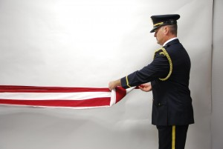
First American Flag Triangle Fold
The first triangle fold is “open end to open end” which means your left hand moves first.
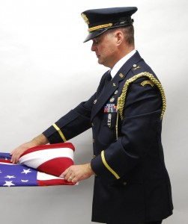
First American Flag Triangle Fold into the Canton
Again, as a guide, the first fold into the canton (the blue field) should fall within the first two stars. This helps you know how much flag is left and when you will probably have to stop to tuck in the remaining the flag material.
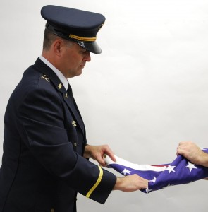
Fold for the Tuck
This fold, is made from the remaining material on the angle side to facilitate the material not bunching up.
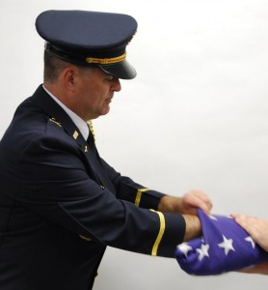
The American Flag Fold: The Tuck
You need to tuck the material as flat as possible, that might mean pushing your hand all the way into the flag and that’s OK.

