United States Coast Guard Auxiliary

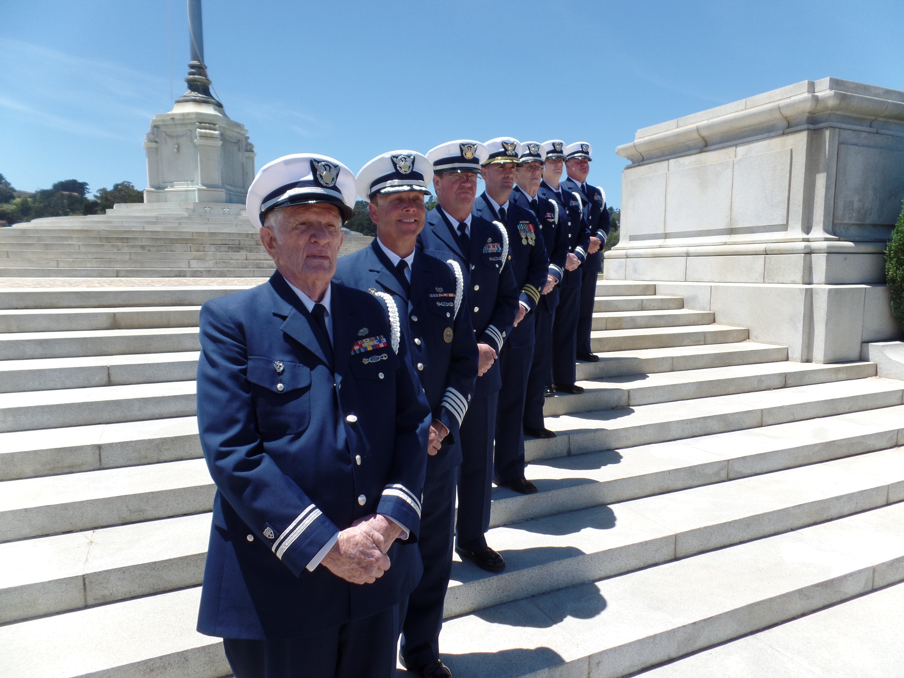

Honor/Color Guard
Standard Operating Procedures

Overview/History:

The history of the United States Coast Guard Auxiliary District 11 NR Honor/Color Guard is one of patriotism, dedication, support and fellowship. We have strived to be professional, diverse, inclusive, and a true asset to those we serve.
Our District Honor Guard officially formed in 2011 to present at the initial dedication of the Auxiliary Memorial on Coast Guard Island. Many members volunteered to present. Some had prior military experience and some had none. Some members had previous Honor Guard experience although most did not have that training background.
The team trained for several months on weekends before the event and spent quite a bit of time in conversation with our counterparts in District 11 SR as well as with the United States Coast Guard Ceremonial Team. We received permission from DIRAUX Chareonsuphiphat, OTO Danny Kilberger and Commodore Perata as well as support from the Ceremonial team to wear an Honor Guard uniform (Service Dress Blue Uniform with a shoulder cord and device) primarily modeled after and approved by the Ceremonial team.
After the successful initial event, the team opted to stay together and received authorization from the DIRAUX , OTO and Commodore to do so. The next four months were spent networking with other Honor Guards and extensive collaborations with the Ceremonial team as well as Coast Guard Island's Base Honor Guard to develop a respectful and credible Honor Guard. We reviewed numerous areas related to Honor Guard development including attire and aligned ourselves as much as possible with the high standards of the USCG Ceremonial team who offered tremendous support and guidance.
Subsequently, we collectively collaborated and developed a list of requirements for Honor Guard members, a structure which included an elected Captain and Chief, a creed, a Performance Qualification Standard which includes both written and performance based assessments/requirements, a PowerPoint, a challenge coin, a website (cghg.weebly.com), training and tasking schedules, a Code of Conduct, grooming specifics and uniform guidelines which include an approved and reasonably priced device from a reputable firm and cord which adheres as much as possible with the Ceremonial team uniform.
Our Honor Guard had been granted permission to train with the Ceremonial team in Alexandria Virginia when they came out west to commission the USCGC Stratton in March 2012. The ceremonial team graciously extended their stay three additional days to train our group. Joining us in that training was the Coast Guard Island Base Honor Guard Team.

Aside from the initial sanction of our group from DIRAUX, the OTO and the District Commodore, we have currently received support/sanction/authorization from all
D11 NR DIRAUX, (Chareonsuphiphat, Sumrok and Lynn), OTOs (Kilberger, James and Lavelle) and Commodores (Perata, Collins, Thomas and Smith) since 2011. After submitting our PQS to the USCG Ceremonial team, training with them and soliciting their support in our development, LT Qureshi of the Ceremonial team recommended and approved our wearing of the device and the rope as well as our positional titles.
Since our inception we have participated in numerous events including many professional sporting events, changes of watch, District Training's, funerals, memorials, joint taskings, parades, ship christenings, harbor ceremonies, birthdays, retirements, training events, etc. Every tasking and presentation is a privilege and an honor for our members to participate in. The opportunity to offer solace and comfort when participating at funerals and memorials is priceless and touches all who are involved.
We have participated in many notable taskings; Among them have been: marching in the 75th anniversary of the attack on Pearl Harbor in Hawaii (the only Auxiliary Honor Guard to do so) and leading the Ceremonial Team; presenting at a private function for the Commandant of the United States Coast Guard; presenting at a ceremony for the most decorated Air Squadron from the Vietnam War and honoring a fellow shipmate who turned 100 years young.
Commander Williamson (retired USCG) ) has thirty years of Honor Guard experience and joined our ranks three years ago. Commander Williamson is our Honor Guard Chief and is also an adviser/trainer. He was the first recipient of our Douglas Munro Award. Our second Douglas Munro award winner is the Honorable Chester Bartalini who is now serving as the Honor Guard Captain.
Our vision is to create a core group of skilled and qualified Honor Guard members with the appropriate training and skills who were then ready and willing to pay tribute to our great country, its rich history and all deserving military, auxiliary and civilian persons.

Our Honor Guard is skilled and trained to serve at a variety of ceremonial functions, parades, memorials, funerals and other appropriate events. The members themselves are expected to serve as stellar examples of our core values and the Honor Guard Creed. Honor Guard members are expected to exemplify proper uniform wear, military customs and courtesy, grooming standards and appropriate decorum. Participation in the Honor Guard is very rewarding but also requires hard work, commitment, discipline, attention to detail, pride, poise, the pursuit of perfection, passion, patriotism and patience.

Many individuals and organizations have been instrumental in our development and have been very supportive of our Honor Guard. We serve at the discretion of our leadership and strive to be Honorable and live up to the expectations of our Honor Guard Creed. We would like to extend our sincerest gratitude and salute all who have offered their support and guidance. The intrinsic rewards of honoring our Country, deserving servicde men and women as well as representing all Coast Guard forces is immeasurable.

This Standard Operating Procedure Manual describes the expectations and goals of our Honor Guard.

___________________________ ___________________________
D11NR Commodore DIRAUX

___________________________ ___________________________
Honor Guard Captain Honor Guard Chief/Active Duty

Honor Guard SOP Record Of Changes

Change | Date of Change | Date Entered | Authorized By

Table of Contents

Overview/History Page 2
Record of Changes Page 5
Table of Contents Page 6
References Page 7
Definitions Page 8
Requirements Page 8 Organization Structure Page 9
Position Responsibility and Election Criteria Page 10
Creed Page 13
PQS Introduction Page 14
Tasking Levels Page 15
Standards Guide Page 16
Standards Glossary Page 23
Mentor Tracking Form Page 25
Final Approval Page 31
Code of Conduct Page 32
U.S. Coast Guard Core Values Page 33
Common Colors Presentation Commands Page 33
Positions and Order of Flags Page 36
Standard Military Commands Page 36
Rifle Drill Page 38
Marching Commands Page 38
Tasking Line Up Considerations Page 39
Uniforms, Grooming and Weapons Guidelines Page 40
Four Person Flag Fold Protocols Page 42
Honor/Color Guard Exam Page 50
Travel/Reimbursement Policy Page 59
Adherence to Manuals Page 59
Notes Page 60

References

Subject: Untied States Coast Guard Auxiliary Honor Guard

  - Marine Corps Drill and Ceremonies Manual (Marine Corps Order P5060.20), COMDTINST M5060.11B
  - United States Flag Code, Title 4 of the United States Code
  - U.S. Coast Guard Auxiliary Manual, COMDTINST M16790.1F
  - U.S. Coast Guard Auxiliary Flags and Ceremony Guide
  - U.S. Coast Guard Auxiliary Memorial Guide Book
  - United States Coast Guard Ceremonial Honor Guard Website http://www.uscg.mil/honorguard/
  - United States Coast Guard Auxiliary D11NR website
https://cghg.weebly.com/

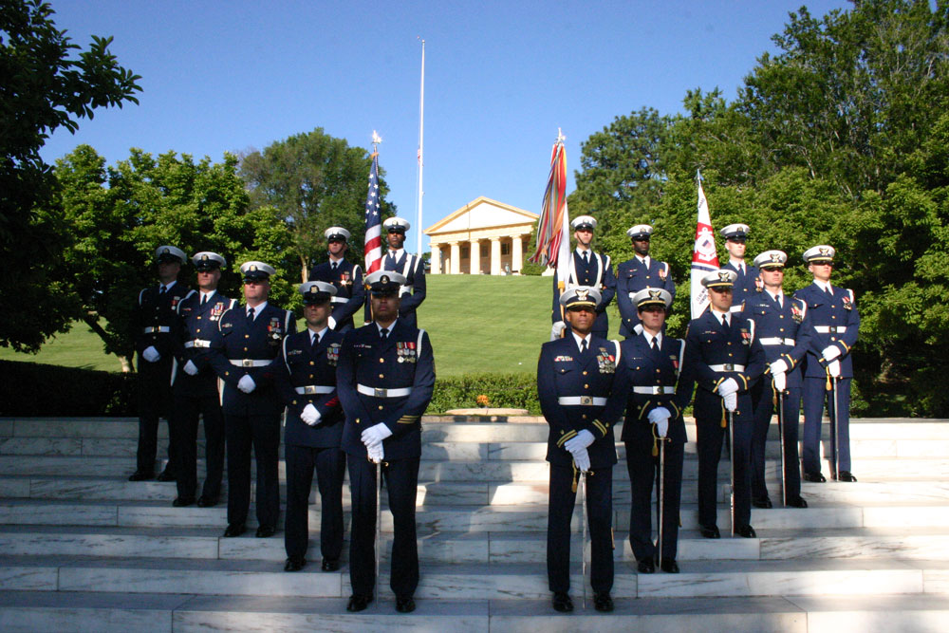

Definitions:

- Color Guard: A color guard carries, escorts, displays, posts and recovers the national colors and any other appropriate flag(s) during a ceremony. It may be armed or unarmed with non-firing ceremonial rifles.
- Honor Guard: An Honor Guard performs the ceremonial function of honoring an individual or group, living or deceased, by standing guard, assisting, escorting, or otherwise participating in a ceremony or activity without use of the national or state color. It may be armed or unarmed with non-firing ceremonial rifles. Exception: When a national, state or unit color is a part of a funeral, memorial or burial ceremony as a casket drape or other acceptable use of a flag, its handling may be a part of the responsibility of an Honor Guard.
- Blanket Orders: The term “blanket orders” refers to standing orders under which a person or persons, under the direction and or awareness of proper authority, can be considered under “Auxiliary non-reimbursable” orders for duty and or training without having to secure separate orders for each incidence of duty.

Requirements

- Personal Qualities: Must be stable, of excellent character and discretion, and unquestioned loyalty to the United States.
- Characteristics evaluated for selection: Maturity, self-control, objectivity, forthrightness, sincerity, attitude toward the service, others and themselves, cooperation and motivation.
- Must not have visible tattoos and adhere to the grooming standards of the Auxiliary Manual.
- No beards or mustaches are permitted; the face must be clean shaven at all times.
- Flotilla Commander or Honor Guard member recommendation
(Items the FC or HG will take into consideration when recommending an applicant will be if the person is in good standing within the flotilla, attends meetings regularly, wears the USCGAUX uniform properly for meetings, is physically capable of honor guard demands, cooperates in a team setting and has military bearing.)
- Applicant must be in BQ status unless applying in an approved joint venture status.
- Pass the 50 question exam with a score of 85% or better.
- Attend training sessions regularly. Typically, 75% of all sessions is expected.

- By the ninth training session, the applicant must have secured and be prepared to display the required uniform items necessary to be a participant of the honor guard. The Captain of the Honor Guard will identify the necessary items and approximate costs. Items typically will be purchased at the applicants own expense. Typical required items: Service Dress Blue Uniform, Combination cap, White Dress Shirt, White Military Police Belt, Nickel Buckle, Blue Uniform Tie, White Glove and Dress Shoe Cordovan.
- Demonstrate basic drill marching/military maneuvers. To include but not limited to: Saluting, Position of Attention, Forward March, Facing Movements, etc.
- Adhere to all guidelines of the United States Coast Guard Auxiliary Ceremonial Honor Guard.
- Do nothing to disgrace yourself, your shipmates, the United States Coast Guard, the Coast Guard Auxiliary or the United States of America.
- Members may not be in a non-PQS qualified status for more than 18 months since the outset of attending their first meeting.
- Final decision of acceptance into the Honor Guard rests with the Captain of the Honor Guard/QE.
- Participate in a formal “going-up” ceremony.
- Serve with Pride, Poise, Devotion and Honor
- Strive for Perfection, Respect and Excellence
- Upon completion of the above, the member will be presented a White Ceremonial Shoulder Cord.

Organization Structure

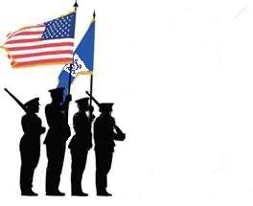
(In descending order or authority)
DIRAUX Commander
DIRAUX OTO
District Commodore
District Chief of Staff
District Public Affairs Officer, DSO-PA
Honor Guard Captain
Honor Guard Chief

Position Responsibilities and Election Criteria

Captain/Operations Officer:
The Captain is the primary contact and leader of the District Honor Guard.
The Captain is responsible for setting up meeting schedules which also include training and solicits/approves taskings. The Captain also identifies the POC for events and notifies the webmaster what specifically he wants on the tasking page. The Captain can exclude members of the team for Code of Conduct violations and can re-instate them with a unanimous team vote should a member be removed. The Captain would also have the final vote in a Code of Conduct violations matter. The Captain sets the lineup for an event and coordinates with the Chief and the POC for events. The Captain also responds to all requests that come through the Honor Guard website (cghg.weebly.com) as well as those through flotillas, division, district, sector or the active duty. The Captain serves as a QE for the PQS and as a protocol advisor for the District Commodore. The Captain (if approved by the District Commodore) should participate in District meetings as well as provide written reports regarding Honor Guard activities/needs/concerns/protocols, etc. The District Honor Guard Captain reviews other Divisions/Flotillas Color Guards and Honor Guards within the District to ensure that they are compliant with standards and protocols. Division and Flotilla Color Guards/Honor Guards will be led by a person referred to as the point of contact or lead. If one has not been selected it will be the person who carries the National ensign. The Captain is elected into his positon during the month of November in the last year of their term. The length of term is two years from January of the immediate year following the election. The Captain may relinquish their position at any time and a new Captain will be voted on by the membership. Their tenure will be the remainder of the original term of the Captain who is relinquishing duties. The new Captain remains eligible for the position for a complete two-year term if they desire and will be voted on by team members in November as previously described. In the event of a tie vote, the District Chief of Staff will determine the winner. Prior Captains can return to their positon (if elected) after a one term hiatus. If a Captain needs to relinquish their duties for an interim basis not to exceed two-months in length (two meetings) then the Chief will assume the Captaincy status and maintain both positions. If the Captain needs to relinquish duties longer than two months then a new Captain will be voted on by membership as soon as possible. The vote will take place on-line. Prospective Captain candidates may contact members via email and present their resume/direction regarding the position up to two days before the election. The District Chief of Staff or their designee will coordinate and sanction the vote.

Chief/Training Officer:
The Chief is similar to an S-3 (training officer) and is responsible for training. When the Captain has established a meeting schedule in which training is to be conducted, the Chief does the training and/or secures others to assist in the training depending on the skills being taught. The Chief will coordinate with members and the equipment person to ensure that the necessary equipment is available for taskings. If equipment is faulty or damaged they will coordinate with the equipment person to ensure that it is repaired, discarded or replaced. If it is discarded, they need to let the Captain know. The Chief serves as a QE for the PQS. The Chief is voted into his positon during the month of November in the last year of their term.

The length of term is two years from January of the immediate year following the election. The Chief may relinquish their position at any time and a new Chief will be voted on by the membership. Their tenure will be the remainder of the original term of the Chief who is relinquishing duties. They remain eligible for vote for a complete two year term if they desire. In the event of a tie vote, the District Chief of Staff will determine the winner. Prior Chiefs can return to their positon if elected after a one term hiatus.

Quartermaster:
Retains and maintains equipment and ensures its availability for members, training and taskings. When equipment is faulty or damaged and needs to be replaced they need to bring that to the attention of the Chief. A voluntary position appointed/sanctioned by the Captain. No term limit.

Keeper of Records:
The Keeper of Records maintains pertinent data from minutes, contracts, rules, etc.
A voluntary position appointed/sanctioned by the Captain. No term limit.

Webmaster:
The webmaster keeps and maintains the website.
A voluntary position appointed/sanctioned by the Captain. No term limit.

ADSOPA:
The Assistant District Affairs Staff Officer for Public Affairs (if approved and appointed by the DSO-PA) will provide written reports/pictures of events/activities that the Honor Guard participates to the DSO-PA as well as for various other publications when sanctioned.

Finance:
The finance officer maintains pertinent financial data and conducts approved fund raising. The finance officer shares with the Captain and the team in general at all meetings via written or verbal report the status of funds/expenses/etc. Expenses of no more than $50 total quarterly will be considered discretionary and can be sanctioned by the Captain. They are to be recorded and shared with the team at the next meeting and compiled in the finance report. Any and all proposed expenses totaling more than $50 quarterly need to be voted on by the team prior to allocating any funding. Two thirds of the team present (or at the minimum a quorum of 6) at the meeting for which the allocation of the expense is discussed need to approve the expense before it can be sanctioned. This expense needs to be in the report of the next meeting.
A voluntary position appointed/sanctioned by the Captain. No term limit.

POC:
The point of contact for an event is the person who is directly responsible for acting as a liaison between the Honor Guard and an event for which the Honor Guard is tasked. The POC will coordinate activities with the Master of Ceremonies/Director including but not limited to, music, presentation details, etc., and will advise of any idiosyncrasies, including but not limited to; when to arrive, where to meet, plans on where changing rooms are located, water, how equipment will be transported (liaison with the Quartermaster) and how the team will fall out and transition when the event is concluded. POCs for events are typically voluntary but are appointed/sanctioned by the Captain. Term expires when the event is complete.

Tasking Committee:
The tasking committee (3 or more members) work in conjunction with the Captain to seek out acceptable events/taskings in addition to established activities such as the District Memorial and COWs that we typically perform at.
When an event is established and sanctioned, the tasking committee will then appoint a POC who will serve as the lead contact for the event, coordinating details with the participating members. A voluntary position appointed/sanctioned by the Captain. No term limit.

Funeral/Memorial Coordinator:
The funeral/memorial coordinator works in conjunction with the Captain in addressing funeral and memorial requests. The Coordinator then serves as the primary POC for the event unless another has been designated. The Coordinator or appointed POC becomes the primary liaison between the Honor Guard, family and other potential joint services. It is the responsibility of the Coordinator to ensure that all proper funeral/memorial etiquette protocols are observed as well as adhere as much as possible to the wishes of the family. A voluntary position appointed/sanctioned by the Captain. No term limit.

Creed

United States Coast Guard Auxiliary Honor Guard Creed
I am an Honor Guardsman and this is my Creed.
I will stand with Pride beside my Coast Guard Family.
I will maintain Poise at all times.
I will strive for Perfection.
I will Honor all who have served our country honorably.
I will Respect the Honor Guard Mission.
I will render Devotion unto this sacred duty.
By wearing this cord and device, I am committed to Excellence as a way of life.

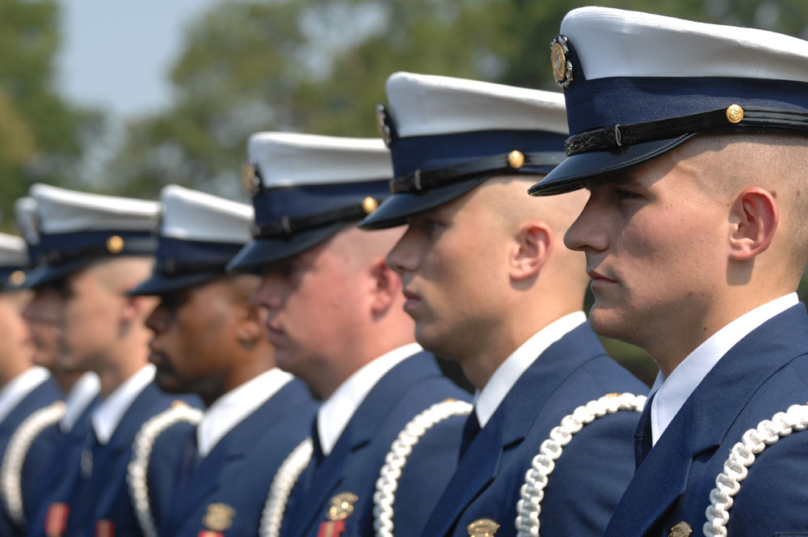

PQS Introduction

This standard establishes the policies, protocols and procedures for training, qualification and certification of Auxiliary members for honor guard duty.
An honor guard is a ceremonial unit, often associated with the military, fire or police departments and composed of volunteers who are carefully screened for their loyalty, skills and commitment to service. Only those persons who are highly motivated and maintain exceptionally high standards of appearance and conduct and show aptitude for ceremonial duty are likely to be considered.
A primary role for honor guards in the United States and some other countries is to provide funeral honors for fallen comrades and to guard national monuments. An honor guard may also serve as the "guardians of the colors" by displaying and escorting the national flag on ceremonial occasions at various functions. In the Coast Guard family this may include Change of Watches, District Training events, retirements, dedications, banquets, memorial ceremonies, sporting events, recognition ceremonies, etc. Honor guards may serve as ambassadors to the public, presenting a positive image of their service, and assisting with the recruiting effort. The Auxiliary Honor Guard represents the Auxiliary and the United States Coast Guard in the highest of manners to the public.
The qualification of Auxiliary Honor Guard members must be linked to standards where excellence and selective measures are used to ensure the highest caliber of members. Honor Guard members may then be qualified and certified with assurance that they have been trained to expected minimum standards and voluntarily commit to the honor guard code/creed.
This standardized level of qualification will allow increased interoperability with Coast Guard units and be a true task force multiplier. The qualification detailed in this Standard is not related to the AUXOP program, but rather is an entirely new qualification program within the Public Affairs (PA) Department of the Auxiliary. Honor Guard individuals currently eligible are encouraged, but not required to meet the qualification detailed in this Standard. After the effective date of this Standard, completion of the qualification detailed in this Standard is required for all new honor guard members

Tasking Levels for Coast Guard Auxiliary Honor Guard

1. National United States Coast Guard Ceremonial Team Participation
2. Base Honor Guard Augmentation
3. Station Augmentation
4. National Events
5. District Events
6. Division Events
7. Flotilla Events
8. Community Events

Events to include all activities that a typical honor guard would participate in and would bring honor to the United States, the United States Coast Guard and the United States Coast Guard Auxiliary. Events would include and not be limited to the following: Funerals, presentation and securing of the colors, speeches, memorials, training events, memorials, changes of watch, dedications, banquets, recognition ceremonies, parades, scouting functions, sea cadet activities, etc.

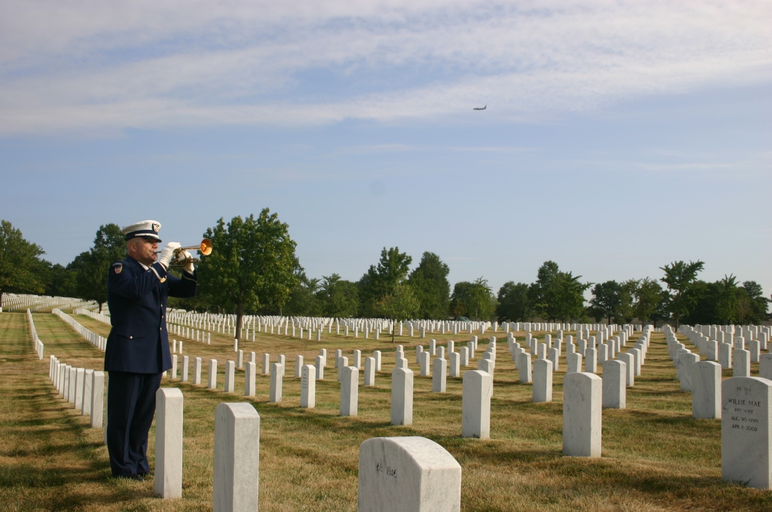

Standards Guide

The Honor Guard Qualification Standards Guide is designed to be an integral part of the qualification process. It contains a collection of tasks that must be learned, practiced, and performed by the candidate. In addition, it contains a set of reading and practical assignments that provide policy and background information for the tasks.

1. Description of Tasks

2. Task designation

3. Task Identification
Tasks are identified by designation. For example: HGQ-1-1-1
a. (HGQ) - Volume designation – Honor Guard Qualification
b. (01) - Task Group designation number
c. (02) - Task order designation number
d. (HGQ) – Task Qualification number

4. Task – The knowledge or skill objective to be performed.

5. Reference - Information sources used by the trainee and instructor to obtain the background necessary for task performance.

6. Conditions - The environmental and physical circumstances in which the tasks must be performed. Any tools or special equipment needed for the completion of the task are listed here. The conditions listed with each task must be met

7. Standards – The specific outcome of the task. Successful task completion is a function of how well a student is able to complete the task without assistance.
a. Trainees must be able to cite, from memory, specific information and procedures.
b. Instructors (mentors) may wish to ask questions concerning particular steps for accomplishment in order to evaluate the trainee's total comprehension of the subject matter.
c. Trainees must be able to perform all performance tasks without prompting or assistance from the instructor. Each task demonstration must follow the correct sequence with little or no hesitation between the steps for accomplishment.

8. Performance Criteria - These steps delineate the procedure that is best followed for performing each task. They can be utilized two basic ways.
Some steps for task accomplishment follow exact procedures that are required for performing a particular operation or using a specific piece of equipment, while others serve as general
guidelines for task completion. They provide a performance check-off that can be used by the mentor to determine trainee performance when the trainee performs the task.

9. Accomplished – On the Mentor Tracking Form (Appendix G) the designated instructor (mentor) must print his/her name, sign and date this line attesting that the trainee successfully performed the task in accordance with the prescribed standards.

10. Comments - The comment section can be used to describe circumstances or conditions that might have a bearing on task completion. Failure to perform any element or unsatisfactory performance of an individual element should be noted in the comments section for the task. If the task is completed under more arduous circumstances than those described, a notation should be made.

B. Steps in the Qualification and Certification Process

1. Assignment to the training program - The trainee initiates entry into the qualification program by meeting the requirements as noted in this requirements section of this standard and then contacting the Flotilla Commander (FC) who will then endorse their participation or give guidance as to what requirements must still be met prior to contacting the honor guard captain with his recommendation.

2. Assignment of Mentor – Once a member meets all requirements and is accepted into the program a mentor is assigned by the Honor Guard Captain as the trainee’s primary instructor.

3. Completion of qualification guide - The trainee completes the qualification guide. To accomplish this, he/she follows the procedure below.

a) Step Procedure
1) Trainee selects a task.
2) Trainee completes reading assignment.
3) Task is demonstrated to trainee by the mentor.
4) Trainee practices the task.
5) Trainee demonstrates proficiency at least to the task standard.
6) Task is signed off by the mentor or other qualified honor guard member.
7) When all tasks for the desired level of certification are completed, the honor guard Captain and Honor Guard Chief reviews the completed task list, and test the candidate in an oral and practical demonstration of skills selected from among each task group. The candidate then participates in a “going-up” ceremony at an agreed upon time and place. The “going-up” ceremony is the culmination of basic training and the candidate’s final exam process. Formal uniform may be required. Upon successful completion of the “going-up” ceremony the candidate is accepted into the honor guard unit.

4. Certification - Upon successful completion of all tasks and successful demonstration in the “going-up” ceremony, the trainee will submit the signed-off task list to the Honor Guard Captain for approval and submission to the ADSO for Public Affairs (ADSO-PA) for verification submission to DIRAUX for certification.

5. Time Frame - Trainees shall complete all elements of the PQS within eighteen months from initial tasking sign-off. Should the PQS not be completed within eighteen consecutive months, the trainee will be removed from the program. Trainees so removed may reapply.

Personal Qualification Standard 1
Honor Guard (HG)
A. Honor Guard (HG) Duties
Honor Guard members may be assigned to duty at any identified tasking according to schedules arranged with the Honor Guard Captain, the Order Issuing Authority (OIA), district public affairs officer (DSO-PA), other elected district officers or a United States Coast Guard representative. Honor Guard members will follow all protocols and courtesies expected of an honor guardsman and discharge their duties in an honorable and respectful fashion. They will act in a dignified manner so as to bring honor to the United States, the United States Coast Guard and the United States Coast Guard Auxiliary. Honor Guard members will adhere to all guidelines within the U.S. Coast Guard Auxiliary Manual Honor Guard members are directly responsible for fulfilling duties of the missions they are assigned and for coordinating activities with the OIA or cognizant Coast Guard unit as needed.
The Honor Guard member must contact and coordinate with the Honor Guard Captain, OIA or cognizant CG unit in cases of distress, emergency or mishap.

Trainee Name: _______________________________
EMPID_____________________________________

B. Tasks for Qualification
Task HGQ /1-9/01/HG
Task: Perform Basic Formation Skills
References: United States Marine Corps Drill and Ceremonies Manual
Conditions: Task must be performed in a group/team setting. Task must be done at a monthly training session. Defining formation terms will be done in a one on one setting.
Standards The trainee must perform basic formation skills without error and in coordination with the team with which they are performing.
Performance Criteria: Complete the basic skills as noted:

_____ Dress Left/Dress Right
_____ Dress Front/Dress Back
_____ Stand at Attention
_____ At Ease
_____ Parade Rest
_____ Fall In/Fall Out
_____ Be Prepared to Define Formation Terms: For Example; Column; Depth; Formation; etc.

Sign-Off Member: ________________________
EMPID__________________________________

Task HGQ /1-9/02/HG
Task: Perform Basic Marching Skills
References: United States Marine Corps Drill and Ceremonies Manual
Conditions: Task must be performed in a group/team setting. Task must be done at a monthly training session.
Standards The trainee must perform basic marching skills without error and in coordination/step with the team with which they are performing.
Performance Criteria: Complete the basic skills as noted:

_____ Facing Movements
_____ Colors
_____ Color Wheel Turn
_____ Mark Time
_____ Walking in Rhythm
_____ Column Movements
_____ Step Off Marching
_____ Identify the Four Basic Commands and Show a Command Voice
_____ Identify Marching Terms: For example, Cadence, As You Were, etc.

Sign-Off Member: ________________________
EMPID__________________________________

Task HGQ /1-9/03/HG
Task: Perform Basic Manual of Arms Skills
References: United States Marine Corps Drill and Ceremonies Manual
Conditions: Task must be performed in a group/team setting. Task must be done at a monthly training session.
Standards The trainee must perform basic manual of arms skills without error and in coordination/sync with the team with which they are performing.
Performance Criteria: Complete the basic skills as noted:

_____ Order Arms
_____ Port Arms
_____ Present Arms
_____ Shoulder Arms
_____ Shoulder Arms with a Flag
_____ Port Arms with a Flag
_____ Demonstrate a Strong Grip on the Staff and a V Grip on the Staff

Sign-Off Member: ________________________
EMPID__________________________________

Task HGQ /1-9/04/HG
Task: Pass Uniform Inspection/Proper Wear
References: Auxiliary Manual/ http://www.uscg.mil/honorguard/, United States Coast Guard Uniform Manual. United States Coast Guard Uniform fitting and alteration Manual
Conditions: Task may be performed in a group/team setting or in a one to one meeting. Task must be done over a period of three monthly training sessions, one uniform per session.
Standards The trainee must properly wear the uniform/ribbons that has been chosen according to the Auxiliary Manual and/or the Honor Guard unit with which they are performing. The uniform needs to fit properly and present to the highest standards of the United States Coast Guard and the United States Coast Guard Auxiliary.
Performance Criteria: Complete the basic skills as noted:

_____ ODU—Proper fit, boots bloused, laces tucked, name tapes properly worn, no loose strands, cover properly worn, boots polished, etc.
_____ Service Dress Blue--Proper fit, ribbons/devices properly located on the ribbon rack and worn properly as measured by a ruler, name tag worn properly and straight, no loose strands, cover properly worn, shoes shined, clothes pressed, etc.
_____ Tropical Blue Uniform--Proper fit, ribbons/devices properly located on the ribbon rack and worn properly as measured by a ruler, name tag worn properly and straight, no loose strands, cover properly worn, shoes shined, clothes pressed, etc.
_____ Be able to answer questions regarding uniform wear according to the Auxiliary Manual

Sign-Off Member: ________________________
EMPID__________________________________

Task HGQ /1-9/05/HG
Task: Perform and Be Aware of Basic Military and Auxiliary Courtesies/Rank
References: Auxiliary Manual/ http://www.uscg.mil/honorguard/, Auxiliary Drill and Ceremonies Manual, United States Marine Corps Drill and Ceremonies Manual
Conditions: Task must be performed in a group/team setting. Task must be done at a monthly training session.
Standards The trainee must perform basic military and auxiliary courtesy awareness without error.
Performance Criteria: Complete the basic skills as noted:

_____ Execute a Proper Salute
_____ Execute a Slow Ceremonial Salute
_____ Identify the Ceremonial Salute Cadence

_____ Identify Basic Uniform Insignia
_____ Identify Basic Ribbon Placement

Sign-Off Member: ________________________
EMPID__________________________________

Task HGQ /1-9/06/HG
Task: Perform and Demonstrate Basic Funeral Responsibilities and Awareness
References: Auxiliary Manual/ http://www.uscg.mil/honorguard/, Auxiliary Drill and Ceremonies Manual, Auxiliary Memorial Guide Book
Conditions: Task must be performed in a group/team setting. Task must be done at a monthly training session.
Standards The trainee must perform basic funeral responsibilities and skills without error and in coordination with the team with which they are performing.
Performance Criteria: Complete the basic skills as noted:

_____ Two Man Flag fold
_____ Four Man Flag fold
_____ Placement of Flag on Casket
_____ Memorization of Primary Next of Kin (PNOK) Statement
_____ Proper triangular Flag Preparation
_____ Demonstrate proper burial at sea procedure

Sign-Off Member: ________________________
EMPID__________________________________

Task HGQ /1-9/07/HG
Task: Demonstrate the proper Hoisting, lowering and folding of National Ensign and additional colors
References: Auxiliary Manual/ http://www.uscg.mil/honorguard/, Auxiliary Drill and Ceremonies Manual, United States Marine Corps Drill and Ceremonies Manual
Conditions: Task must be performed in a group/team setting. Task must be done at a monthly training session.
Standards The trainee must perform basic military and auxiliary courtesy awareness without error.
Performance Criteria: Complete the basic skills as noted:

_____ Properly Hoist the morning colors
_____ Hoist the colors to half staff
_____ Properly retire the colors.

Sign-Off Member: ________________________
EMPID__________________________________

Task HGQ /1-9/08/HG
Task: Additional Tasks: Be familiar with at least three of the following protocols/duties.
References: Auxiliary Manual/ http://www.uscg.mil/honorguard/, Auxiliary Drill and Ceremonies Manual, United States Marine Corps Drill and Ceremonies Manual
Conditions: Task must be performed in a group/team setting. Task must be done at a monthly training session.
Standards The trainee must perform without error.
Performance Criteria: Complete the basic skills as noted:

_____ Rendering Honors for official Visits Ashore and Afloat.
_____ Side boys
_____ Quarterdeck sentry
_____ Fallen Comrades Table & Honors Ceremony
_____ Ringing of ships bells
_____ Sounding of Boatswain’s pipe
_____ Playing of Ceremonial Bugl

Sign-Off Member: ________________________
EMPID__________________________________

Task HGQ /1-9/09/HG
Task: Ceremony Set-up/Flag Etiquette/Going Up Ceremony
References: United States Marine Corps Drill and Ceremonies Manual, United States Flag Code, Auxiliary Manual, Auxiliary Honor Guard Requirements, Auxiliary Flags and Ceremony Guide, Auxiliary Drill and Ceremonies Manual, Auxiliary Memorial Guide Book,
http://www.uscg.mil/honorguard/
Conditions: Task must be performed in a group/team setting. Task must be done at a monthly training session. The trainee may perform the Going Up ceremony in a separate monthly session if requested. The ceremony set-up and flag etiquette portion may be done in ODUs. The Going Up ceremony must be done in the Service Dress Blue Uniform.
Standards The trainee must perform all expected ceremonial skills without error and in coordination with the team with which they are performing. The trainee must exhibit poise in the presentation.
Performance Criteria: Complete the basic skills as noted:

_____ Ceremony Set Up
_____ Team Coordination
_____ Leadership
_____ Flag placement

_____ Going Up Ceremony

Sign-Off Member: ________________________
EMPID__________________________________

Standards Glossary

DEFINITIONS. The following definitions are standard terms used in the Standard

1. Alignment. The dressing of several elements on a straight line.
2. Assembly Area. A designated location for forming units of Unit size or larger in preparation for a parade, review or ceremony.
3. Arms. A term used to normally designate the service rifle but can refer to any weapon. When in formation and a mix of weapons is carried the term arms will be used to designate all types of weapons.
4. Base. The element on which a movement is regulated.
5. Cadence. A rhythmic rate of march at a uniform step.
6. Center. The middle element of a formation with an odd number of elements or the left center element of a formation with an even number of elements.
7. Ceremony. A formal military formation designated to observe a specific occasion.
8. Column. A formation in which elements are placed one behind the other. A section or Unit is in column when members of each squad are one behind the other with the squads abreast of each other.
9. Commander of Personnel (COP). The COP is the senior officer taking part in the ceremony. If an enlisted ceremony the COP is the senior enlisted.
10. Depth. The space from head to rear of an element or a formation. The depth of an individual is considered to be 12 inches.
11. Distance. The space between elements in the direction of depth. Between individuals, the space between your chest and the person to your front. Between vehicles, the space between the front end of a vehicle and the rear of the vehicle to its front. Between personnel in formation (either on foot, mounted, or in vehicles), the space from the front of the rear unit to the rear of the unit in front. Unit commanders, guides, and others whose positions in a formation are 40 inches from a rank are, themselves, considered a rank. Otherwise, commanders and those with them are not considered in measuring distance between units. The color guard is not considered in measuring distance between subdivisions of the unit with which it is posted. In Auxiliarist formations, the distance between ranks is 40 inches.
12. Double Time. Cadence at 180 steps (36 inches in length) per minute.
13. Element. An individual, squad, section, Unit, company, or other unit that is part of a larger unit.
14. Extended Mass Formation. The formation of a company or larger unit in which major elements are in column at close or normal interval and abreast at a specified interval greater than normal interval.

15. File. A single column of personnel or vehicles one behind the other.
16. Flank. The right or left extremity of a unit, either in line or in column. The element on the extreme right or left of the line. A direction at a right angle to the direction an element or a formation is facing.
17. Formation. Arrangement of elements of a unit in line, in column, or in any other prescribed manner.
18. Front. The space occupied by an element or a formation, measured from one flank to the other. The front of an individual is considered to be 22 inches.
19. Guide. The individual (base) upon whom a formation, or other elements thereof, regulates its march. To guide: to regulate interval, direction, or alignment; to regulate cadence on a base file (right, left, or center).
20. Head. The leading element of a column.
21. Interval. The lateral space between elements on the same line. Interval is measured between individuals from shoulder to shoulder and between vehicles from hub to hub or track to track. It is measured between elements other than individuals and between formations from flank to flank. Unit commanders and
those with them are not considered in measuring interval between elements of the unit. Normal interval between individuals is one arm's length. Close interval is the horizontal distance between shoulder and elbow when the left hand is placed on the left hip.
22. Left (Right). Extreme left (right) element or edge of a body of personnel.
23. Line. A formation in which the elements are side by side or abreast of each other. A section or Unit is in line when its squads are in line and one behind the other.
24. Line of March. The line on which individuals or units are to march on.
25. Line of Personnel. The line on which personnel are to form when in formation.
26. Loosened Sling. Indicates a sling adjusted for the movement sling arms.
27. Mass Formation. The formation of a company or larger unit in which the major elements are in column at close interval and abreast at close interval.
28. Muffling. The procedure of draping colors for mourning with a mourning streamer or black bunting. It also refers to the process of muffling the musical instruments of a band for specific types of ceremonies.
29. Pace. The length of a full step in quick time, 30 inches.
30. Parade. A parade is a ceremony that involves the movement of marching units.
31. Parade Sling. A sling that has all excess slack removed and is taught. The keeper is adjusted and locked in a position next to the sling tip. The sling liaison the left side of the rifle.
32. Piece. An individual firearm such as a rifle.
33. Point of Rest. The point toward which all elements of a unit establish their dress or alignment.
34. Quick Time. Cadence at 112 to 120 steps (12, 15, or 30 inches in length) per minute. It is the normal cadence for drills and ceremonies.
35. Rank. A line of personnel or vehicles placed side by side.

36. Review. A review is a type of ceremony that omits certain elements found in a parade, but includes an inspection (trooping the line) not found in a parade.
37. Rigged. This term refers to the condition when uniforms and equipment are properly fitted out in the manner for which they were intended for use. An Auxiliarist is rigged when wearing the prescribed uniform or equipment.
38. Slow Time. Cadence at 60 steps per minute. Used for funerals only.
39. Snap. In commands or signals, the quality that inspires immediate response. In drill the immediate and smart execution of a movement.
40. Step. The distance from heel to heel between the feet of a marching individual. The half step and back step are 15 inches. The right and left steps are 12 inches. The steps in quick and double time are 30 and 36 inches, respectively.
41. Strong Grip. The strong grip is when the thumb is wrapped around the front of the staff with the fingers wrapped to the rear.
42. Unit Leader. Is the individual who is drilling the unit. This can be any individual who is conducting drill or can be those assigned a specific billet such as squad leader, Unit sergeant, Unit commander, etc.
43. “V” Grip. The “V” grip is with the staff placed in the “V” formed by the thumbs and forefinger with the fingers extended and joined.

Mentor Tracking Form

Trainee’s Name:________________________ Member Number: ___________

Mentor/QE’s Name Printed | Mentor/QE’s Signature | Initials | Date:

Section 01
Perform Basic Formation Skills/Awareness
Task | Description | Mentor Signature | Date
HGQ /1-9/01/HG | Dress Left/Dress Right
 | Dress Front/Dress Back
 | Stand at Attention
 | At Ease
 | Parade Rest
 | Fall In/Fall Out
 | Be Prepared to Define Formation Terms: For Example; Column; Depth; Formation; etc.

Section 02
Perform Basic Marching Skills
Task | Description | Mentor Signature | Date
HGQ /1-9/02/HG | Facing Movements
 | Colors
 | Color Wheel Turn
 | Mark Time
 | Walking in Rhythm
 | Column Movements
 | Step Off Marching
 | Identify the Four Basic Commands and Show a Command Voice.
 | Identify Marching Terms: For example, Cadence, As You Were, etc.

Section 03
Perform Basic Manual of Arms Skills
Task | Description | Mentor Signature | Date
HGQ /1-9/03/HG | Order Arms
 | Port Arms
 | Present Arms
 | Shoulder Arms
 | Shoulder Arms with a Flag
 | Port Arms with a Flag
 | Demonstrate a Strong Grip on the Staff and a V Grip on the Staff

Section 04
Pass Uniform Inspection/Proper Wear
Task | Description | Mentor Signature | Date
HGQ /1-9/04/HG | ODU—Proper fit, boots bloused, laces tucked, name tapes properly worn, no loose strands, cover properly worn, boots polished, etc.
 | Service Dress Blue--Proper fit, ribbons/devices properly located on the ribbon rack and worn properly as measured by a ruler, name tag worn properly and straight, no loose strands, cover properly worn, shoes shined, clothes pressed, etc.
Tropical Blue Uniform--Proper fit, ribbons/devices properly located on
the ribbon rack and worn properly as measured by a ruler, name tag worn properly and straight, no loose strands, cover properly worn, shoes shined, clothes pressed, etc.

 | Be able to answer questions regarding uniform wear according to the Auxiliary Manual

Section 05
Perform and Be Aware of Basic Military and Auxiliary Courtesies/Rank
Task | Description | Mentor Signature | Date
HGQ /1-9/05/HG | Execute a Proper Salute
 | Execute a Slow Ceremonial Salute
 | Identify the Ceremonial Salute Cadence
 | Identify Basic Uniform Insignia
 | Identify Basic Ribbon Placement

Section 06
Perform and Demonstrate Basic Funeral Responsibilities and Awareness
Task | Description | Mentor Signature | Date
HGQ /1-9/06/HG | Two Man Flag fold
 | Four Man Flag fold
 | Placement of Flag on Casket
 | Memorization of Primary Next of Kin (PNOK) Statement
 | Proper Triangular Flag Preparation

Section 07
Demonstrate the proper Hoisting, lowering and folding of the National Ensign and additional colors
Task | Description | Mentor Signature | Date
HGQ /1-9/07/HG | Properly Hoist the morning colors
 | Hoist the colors to half staff
 | Properly retire the colors

Section 08
Rendering Honors for official Visits Ashore and Afloat
Task | Description | Mentor Signature | Date
HGQ /1-9/08/HG | Side boys
 | Quarterdeck sentry
 | Fallen Comrades Table & Honors Ceremony
 | Ringing of ships bells
 | Sounding of Boatswain’s pipe
 | Playing of Ceremonial Bugle

Section 09
Ceremony Set-up/Flag Etiquette/Going Up Ceremony
Task | Description | Mentor Signature | Date
HGQ /1-9/09/HG | Ceremony Set Up
 | Team Coordination
 | Leadership
 | Flag Placement
 | Going Up Ceremony

Final Approval

Approved and Forwarded to DSO-PA by: Honor Guard Captain

__________________________________________________ __________________________
Print Name Date

__________________________________________________ __________________________
Signature EMPID

Auxiliary District/Division/Flotilla _______/_______/_______

Approved and Forwarded to DIRAUX by District 11 NR Honor Guard Captain

__________________________________________________ __________________________
Print Name Date

__________________________________________________ __________________________
Signature EMPID

Code of Conduct

As a member of the District 11 Northern Region Honor Guard, I agree to comply with the following CODE OF CONDUCT: The basic tenet is to behave responsibly and treat one another with respect, maintain appearance standards and train/perform regularly. We also are to demonstrate honor and pay tribute to the United States of America, it’s honorable and deserving citizens and service representatives as well as respect and honor the United States Coast Guard family and our deserving shipmates.
I. I shall, at all times, conduct myself as a law-abiding, patriotic citizen of the United States of America, pledge allegiance to our Constitution and follow all guidelines as set forth by the United States Coast Guard Auxiliary.
II. While a member of the Honor Guard, I shall never take up arms against the United States of America nor participate in any seditious manner to overthrow our democratic form of government.
III. I shall, at all times, conduct myself in such a fashion as to never bring discredit upon The United States Coast Guard family.
IV. I shall not discriminate against another because of race, creed, ethnicity, national origin, gender, handicap, personal life-style choice and religious belief or, because of any particular station in life as long as nothing noted violates the laws of the United States of America.
V. I will always wear the uniform of the Honor Guard as prescribed in and according to regulations; only at places, events and in such situations as authorized; and while wearing the uniform, conduct myself appropriately. While in uniform I will maintain a clean-cut and professional appearance.
VI. I shall not engage in unethical or dishonorable acts that would bring discredit or shame upon the Honor Guard or the United States Coast Guard family.
VII. I will adhere to the tenets of the Honor Guardsman Creed to the best of my ability.
VIII. I will commit no acts that seriously offend, or expose the Honor Guard or our service to social discredit.
IX. Members have a duty to avoid dishonest acts, displays of indecency, public intoxication, lawlessness, dealing unfairly, indecorum, injustice, acts of cruelty, public vulgarity or ridicule.
X. Members are not to bring discredit or shame upon the Honor Guard or the Coast Guard family. We subscribe to the United States Coast Guard Core Values.
​Violations can lead to immediate dismissal by the Honor Guard Captain, DIRAUX, or District Commodore.

United States Coast Guard Core Values

Honor
Integrity is our standard. We demonstrate uncompromising ethical conduct and moral behavior in all of our personal actions. We are loyal and accountable to the public trust.
Respect
We value our diverse work force. We treat each other with fairness, dignity, and compassion. We encourage individual opportunity and growth. We encourage creativity through empowerment. We work as a team.
​
Devotion to Duty
We are professionals, military and civilian, who seek responsibility, accept accountability, and are committed to the successful achievement of our organizational goals. We exist to serve. We serve with pride.

Common Colors Presentation Commands

When arriving at a venue the POC (or their designee) needs to ensure that the Master of Ceremonies (MC) will do the following:

- Let us know approximately 15 minutes before we present.
- The POC needs to advise the MC to use the following statement or something similar to begin our presentation.
  - “Honor Guard please present the colors”---at which point we began our presentation.
  - When colors have been presented and we return to a position of Shoulder Arms or port arms, the MC will say, “Honor Guard, please post the colors”---at which point we will begin to post the colors. If the MC may begin the presentation with “Honor Guard, please present and post the colors”. If this is done we follow through with our commands.
All Commands should be given by the National Flag Holder in a Command Voice.

Approximately 5 to 7 minutes prior to the event the command should be:
“Honor Guard, Fall In, Cover down”---Members should fall in and cover down

This will be followed by one of the following:
“Honor Guard, Carry Colors”
Sentries come to port arms

Flag bearers come to shoulder arms placing the end of the staff in the cup. Left hand covers the cup, right hand is in front of the face where if the thumb was extended you could touch your nose. Hold the flag vertical and straight. If ceiling height restricts flag bearers from coming to a
shoulder arms position they should hold the staff in a strong V grip with their right hand and the left hand horizontal across their chest while the staff is approximately six inches off the floor.

“Honor Guard, Shoulder Arms”
Sentries come to shoulder arms
Flag bearers come to shoulder arms placing the end of the staff in the cup. If ceiling height restricts flag bearers from coming to a shoulder arms position they should hold the staff in a strong V grip with their right hand and the left hand horizontal across their chest while the staff is approximately six inches off the floor. As soon as movement stops and ceiling height allows, flag bearers will raise the flag and place the staff into the cup. Left hand covers the cup, right hand is in front of the face where if the thumb was extended you could touch your nose.
Hold the flag vertical and straight.

“Forward, March”---move forward with the left foot leading in slow, measured steps.
(March with a slight backward lean, heel striking first and as if on a tightrope)

“Colors” will be the command given when executing a previously agreed upon direction from a mark time march. Mark time march will be called or pre-determined. Use marching in place to readjust spacing.
Please note that “Colors” has no preparatory command.

If “Mark time, March” is called take one step from the command and march in place with a horizontal knee lift. Use marching in place to readjust spacing.

“Detail, Halt”---the group comes to a halt. The command is given on the left foot placement…meaning one more half step with the right and the left foot comes in to strike the heel and assume a 45 degree angle with the right.

When the detail is in front of the audience and it is appropriate to address the MC, the following statement will be given. “The Colors are Present”--- followed by, “Present Arms” at which time the playing of the National Anthem will commence and the sentries move to a position of presentation while all flags except the National, dip. At the conclusion of the National anthem, the command, “Shoulder, Arms” should be given so movement can commence from a position outside of presentation mode. If sentries were in the port position, then the command should be “ready two”. In which case flags and rifles return to a positon from which them can move. If we are presenting from sound only, then the sentries and the flags perform as noted above on the first note of the National Anthem. They are to recover on the final note of the Anthem. For moving flags, 3 counts down, 3 counts up for flags. Sentries present in standard movement.

“Step Off, March” is the command for the unit to step in front of one another, from Lead Sentry (if present) to National and so on to ensure that the National ensign leads when maneuvering to another position. On command, the right portion of the unit, takes one step with the left and another with the right pivoting 90 degrees to cross the front of the line. When the person to the right has moved past the next in line shall execute the similar movement.

“Color Turn, March” is the command used from a stopped position when all members began to mark time while turning in a four count movement in an agreed upon position 90 degrees from where they started. The fifth step from everyone will be a forward step with the left foot.

When flag bearers are posting the colors and come to a halt in front of the flag stand that they will be placing the staff into, they should move the staff from whatever position it was carried there and place the staff above the stand with horizontal outstretched arms.

Another option is to come to the flag stand at a positon of attention.
The command then can be “Prepare to Post Colors” at which time the flag is placed immediately above the hole.

The next command is, “Ready, Post” at which time in unison and authority the flag is plunged into the stand. Follow the next sequence: 1) post 2) attention
3) look and dress the flag high, 4) look and dress the flag middle 5) look and dress the flag low. Hold the flag low 6) Center head

“Flag Bearers, Present, Arms”. At which time flag bearers issue a ceremonial salute (7 seconds up, hold 7 seconds) will be followed by the command “Flag Bearers, Order Arms” (7 seconds return).

Another option is to call “Present Arms”. Rifles come to present arms immediately and flag bearers issue a ceremonial hand salute. “Ready Two” returns sentries to port arms and flag bearers (finish the ceremonial salute 7 seconds down and back to attention.

Additional Movements:

“(Right/Left) Wheel, March” will be the command given when the entire Honor/Color Guard moves as one horizontal line to an agreed upon point in the direction dictated. The line pivots from the middle (half the line going forward/half backward). When the line has turned 180 degrees they continue marking time until the command, “Detail, Halt” is given When marching in a parade: “(Right/Left) Turn, March” Pivot from the direction you will be marching/not from the center.

Emergency Commands:

If marching and the pledge or National anthem begins or an incident interrupts the proceeding, the Lead should immediately instruct the Color Guard to halt via the command, "Color Guard Halt". When the pledge or National anthem ends the lead should instruct the color guard to resume marching to the presentation area via the command "Forward March".
When in position to present and the team is halted, the Lead should make the following request, "Master of Ceremonies, The Colors are present. We respectfully request that you repeat the pledge or National anthem now, thank you". From there, carry on as practiced

Positions and Order of Flags

Lead Sentry
National Flag (Color Guard Lead)
DHS
POW
USCG
AUX
CA
NEV
UT
District
WW2
Trail Sentry

Standard Military Commands

Almost all commands are executed with a preparatory and execution command. Commands that are in lower case are the preparatory commands (commands given to tell you are supposed to do). Commands that are in upper case are the execution commands (commands that tell you to do whatever the preparatory command was).

Basic Commands:

- "ATTENTION": Heels are brought together and on the same line. Feet are turned out equally, forming a 45° angle with each other, knees straight but without stiffness. Arms hanging straight without stiffness at the sides of the body in such a way that the thumbs are along the trouser seams. The backs of the hands are turned away from the body and hands and fingers are cupped naturally. Chest up, shoulders back and level. Eyes looking straight to the front. When assuming the position of attention, bring the heels together smartly and audibly.

- "(Stand) At, EASE": Move the left foot to the left so that the feet are shoulder width apart. This command allows you to relax. Right foot may not move. You may not talk.

- "REST": Move the left foot to the left so that the feet are shoulder width apart. This command allows you to relax. Except for keeping the right foot in place, you may move around and talk.

- "Parade, REST": Move the left foot smartly 12 inches to the left. At the same time the foot is moved, clasp the hands behind the back, palms to the rear, the thumb and forefinger of the right hand clasping the left thumb. As at attention, the knees are kept straight without stiffness, the weight of the body equally distributed, and silence and immobility are maintained.

- "Dress Right, DRESS": Used to get the proper alignment between ranks. Squad leader, head turns left 45° with left arm out. Squad members head turns Right 45° with left arm out. Members will move to the point where their right shoulder is touching the tips of the other persons left hand.

- "Ready, FRONT": Used after dress right dress. Arm goes down. Head looks forward.

- "COVER": The right arm is brought straight up and extended unbent to the front so that the fingertips are barely touching the right shoulder of the person in front to establish correct spacing.

- "RECOVER": The right arm is moved smartly back to the side in the position of attention.

- "Open Ranks, MARCH": Command to open a step between each ranks, used for inspections.

- "Close Ranks, MARCH": Command to close the above described step between each rank.

- "HAND SALUTE": Present arms when not carrying a weapon, or with a weapon at sling arms.

- "Ready, TWO": Command to drop Hand Salute.

- "Right (left), FACE": A turn to the right (left).

- "About, FACE": A complete 180° turn to the right.

Rifle Drill

- "Order, ARMS": On the command, the butt of the rifle will be lowered to the ground touching the side of the right foot with the hand forming a "V" or "Taco Grip" at the barrel. This is the rifle version of ATTENTION.

- "Port, ARMS": Rifle is held upright at an angle across the torso with the muzzle pointed up and to the left. The left hand is on the handguard and the right hand is on the small of the stock, with the right forearm parallel to the ground/deck. The weapon is held at a distance of one fist width away from the chest.

- "Right Shoulder, ARMS": Rifle is moved to the right shoulder, rifle making a 45° angle to the ground, and right forearm parallel to the deck/ground.

- "Left Shoulder, ARMS": Rifle is moved to the left shoulder, rifle making a 45° angle to the ground, and left forearm parallel to the deck/ground.

- "Present, ARMS": Unarmed Members render a hand salute. While armed members will render a rifle salute.

- "Secure, ARMS": Rifle is turned upside down placed under the right shoulder.

- "Inspection, ARMS": Lock open the bolt of the rifle, then glance quickly into the chamber to ensure that the weapon is empty.

Marching Commands

- "Forward, MARCH": forward marching movement in cadence. Begin with your left foot.

- "Double time, MARCH": commence jogging at 180 steps per minute.

- "Half step, MARCH": marching forward at half steps.

- "Route step, MARCH": You no longer need to maintain cadence.

- "Column Right (left), MARCH": A turn to the right(left) while marching.

- "(By the) right (left) flank, MARCH: Every member in the marching movement turns Right (left) at the same time.

- "Column half right (left), MARCH": A half turn to the right (left) while marching.

- "(By my) right (left) oblique, MARCH": Every member in the marching movement makes a half turn to the right (left) at the same time.

- "Squad/Platoon/Company (or appropriate formation designation), HALT": Take one more step then freeze.

Tasking Line Up Considerations

The Honor Guard Captain assigns positions for events or appoints a designee to do so.
Factors that need to be taken into consideration for taskings and positions are:

Training/attendance: Has a member attended training sessions?
Skills: Does the member have the necessary proficiency to do the tasking?
Profile: Is the event high profile/televised/high-ranking gold-side/etc.?
Prior service: A veteran/member in good standing with good attendance may end up being given preference over a more skilled person to “Honor” their prior service if appropriate as determined by the Honor Guard Captain.
Position: A person more skilled at giving commands may be on National, while a person from California may be on the California flag and a person with prior Coast Guard service may be on the Coast Guard flag, etc.

Taskings Conflict:
When taskings conflict with one another and both cannot be completed, the decision for which one the Honor Guard completes will be decided by a team vote. In the case of a tie, the Captain will decide.

PQS
All Honor Guard members in good standing can sign the PQS book of prospective members; however the qualifying examiners for final approval/admission into the Honor Guard are the Captain and/or the Chief.

Douglas Munro Award
The Captain or an appointee by the Captain solicits all active team members, any designated retired members (at Captains discretion) DIRAUX, the District Commodore, DCOS and the District Public Affairs officer to nominate and determine the Munro award recipient. A subsequent ceremony to present the award is also the responsibility of the Captain or their designee. The Captain is ineligible for the award during his tenure in office.

Recruiting
All members should act as recruiters seeking other individuals who meet our basic requirements and share our creed. This includes but is not limited to, presentations at Flotilla/Division/District meetings, trainings, the PCA Fair, public affairs events, etc. We are only as strong and effective as our membership and commitment. To improve we need to secure not only new members, but the right members.

Insignia
When authorized, the Captain of the District Honor Guard may be appointed to Captain status by the District Commodore with all insignia.

Uniforms, Grooming and Weapons Guidelines:

Appearance in uniform is a key element in how the men and women of the United States Coast Guard and the public perceives us. Looking sharp and performing and behaving with the appropriate decorum is how we honor our country and its deserving military and civilian personnel. All members are expected to be responsible for maintaining their own personal appearance as noted within the Auxiliary Manual. Members are also to maintain their uniforms and ensure proper fit and wear of all related items to the highest of standards.

AUTHORIZED UNIFORM ITEMS FOR QUALIFIED HONOR GUARD MEMBERS

- The D11NR Auxiliary Honor Guard has established a derivative from the regular
daily Auxiliary Service Dress Blue and Tropical Blue Long uniforms that visibly stand
out from their normal Auxiliary compatriots. These tasteful and sharp modifications that
demonstrate unwavering military bearing and detail, provide positive attention to the
Auxiliary and can potentially draw on further recruiting into both the Coast Guard
Auxiliary and the Honor Guard. Due to the Honor Guard’s ongoing and tireless
dedication to the Coast Guard, the Auxiliary, and the public for whom the Honor Guard
tirelessly performs their duties, the Honor Guard is hereby authorized by the Eleventh
Coast Guard District Director of the Auxiliary (DIRAUX) to wear these prescribed
uniform modifications.

Service Dress Blues -

(During a prescribed Honor Guard function):
No nametag (guards with rifles can damage uniform or nametag when conducting rifle
movements, for uniformity, all members will not wear nametags).
Military Police Belt, 2”, white web, with large nickel buckle and keepers
White shoulder cord (one color) without pin
“Honor Guard” metal device on left breast pocket, below ribbons
Long White gloves

White, plain non-button collared long-sleeve dress shirt with regular Coast Guard service blue 4-in-hand necktie (women wear a similar shirt and necktie).
Male combination cap, with black chin strap (women may wear either the female or male combination cap).
Silver matte chrome aviator-type sunglasses (when events are outdoors)

(When not conducting a prescribed Honor Guard function):
Nametag will be worn
White shoulder cord (one color without pin)
“Honor Guard” metal device on left breast pocket, below ribbons
White, plain non-button collared long-sleeve dress shirt with regular Coast Guard serge blue 4-in-hand necktie (women wear the same shirt but blue tab tie)
Male combination cap (women wear the female combination cap)
Sunglasses (if desired, when outdoors)

Tropical Blue Long –

Normal Auxiliary Honor Guard uniform, when conducting ceremonial duties, is Service Dress Blues. However, the following dictates when the Tropical Blue Long uniform is worn as a regular uniform of the day:

Nametag will be worn
Dark Blue shoulder cord (one color without pin)
“Honor Guard” metal device on left breast pocket, below ribbons
Standard light blue short- sleeve dress shirt
Male combination cap or garrison cover
Female combination cap or garrison cover
Silver matte chrome aviator-type sunglasses

Operational Dress Uniform (ODUs):

No variations are allowed, however, if a fabric “Honor Guard” device design has
been crafted, this may be worn on left breast pocket underneath the
“U.S. Coast Guard” nametape

- Auxiliary Honor Guard members who have completed all necessary PQS
requirements to be deemed “qualified” may wear the prescribed uniforms and accessories as dictated above. Those members who are not qualified can only wear said uniform accessories in accordance with prescribed Honor Guard duties when actually performing in ceremonies and scheduled events. All members who have satisfied the PQS requirements but have elected to not remain in the Honor Guard may continue to wear the “Honor Guard” device only as it has been earned by that member. Any member who has been removed from the Honor Guard for cause or disciplinary action may no longer wear

any Honor Guard uniform accessory that continues to be worn by Honor Guard members in good standing.

- Weapons will be non-firing ceremonial rifles of the following U.S. service rifles:
  - M 1903 Springfield
  - M1 Garand
  - M14
  - M16

All weapons in any one particular event must be identical.

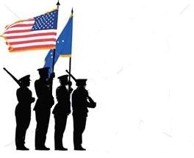
Four Person Flag Fold Protocols

Positions:
Presenter (Head of the detail at the canton, (blue field))
Folder (Opposite End, primarily folding the flag)
Side Attendants (2) (Assist in holding the flag taunt and horizontal)
Steps:
- Assign positions.
- Assemble in position.
- Commence on the Presenter command, “begin”.
- Presenter remains stationary.
- The folder and the side attendants move quietly while folding the flag.
- Side Attendants keep the flag taunt and horizontal
- When the flag is in the final tuck position, only the folder and presenter work to tuck and shape the flag.
- Side Attendants at this time will come to attention.

- When the flag is tucked and shaped it will be placed into the right palm of the presenter with the presenter than placing his left hand on top of the flag. The flag point will be towards the presenter. See picture:
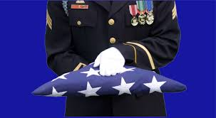

- The folder will now come to attention and issue the command, “present arms”.
- The presenter and side attendants will render a slow 21 count ceremonial salute, (7 seconds up, and then hold 7 seconds).
- After holding for 7 seconds the folder will issue the command, “order arms” at which time the presenter and side attendants will return their salute hand to the attention position in a 7 second descent.
- The presenter will then make a left or right face turn and march to the PNOK.
- Here he will kneel (with his knee never touching the ground) or bend at the waist, make eye contact and make the following statement: (On behalf of the President of the United States and the United States Coast Guard family and a grateful Nation, please accept this flag as a symbol of appreciation for your loved ones faithful service to our Country.)
- At this point the flag is presented to the PNOK and the presenter rises to attention and while staring straight ahead issues a 21 second ceremonial salute.
- The presenter will then make a left or right face turn and depart the area.

Properly Folded American Flag
The above picture is the end result of a properly folded American flag. No other white, except the stars, or red is showing. On one side we have what is called a “1-3″ for the stars and on the other is what is called a “2-4.” On rare occasions a folded flag may show a “1-3-5″ on one side, but the five are not whole stars. There is no meaning to for the stars that show nor for any of the 12 to 13 folds (it depends on what type- material and length- of flag is folded for how many times the triangle folds are made).

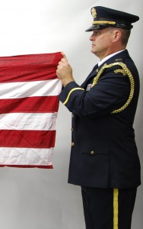
First American Flag Horizontal Fold
For the first horizontal fold of the American flag, the edges do not meet. The edge in my left hand, in the image above, is brought up to half of the first stripe- at the other end of the flag, the same edge is brought up to the horizontal line of the top row of stars. This is a guide to ensure that red does not show once the flag is finally folded and tucked.

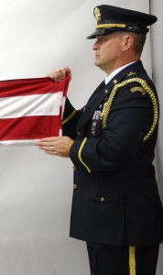
Second American Flag Horizontal Fold
Again, the lower edge is brought up to half the top red stripe and the horizontal line of the top row of stars.
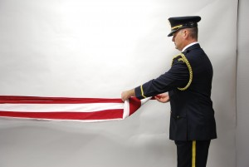
First American Flag Triangle Fold
The first triangle fold is “open end to open end” which means your left hand moves first.

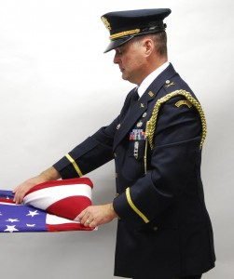
First American Flag Triangle Fold into the Canton
Again, as a guide, the first fold into the canton (the blue field) should fall within the first two stars. This helps you know how much flag is left and when you will probably have to stop to tuck in the remaining the flag material.

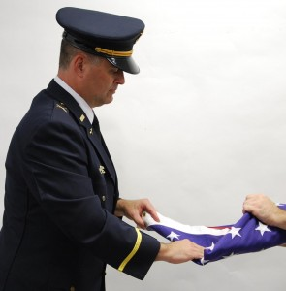
Fold for the Tuck
This fold, is made from the remaining material on the angle side to facilitate the material not bunching up.

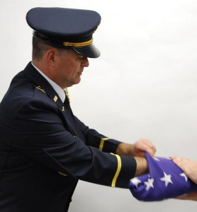
The American Flag Fold: The Tuck
You need to tuck the material as flat as possible, that might mean pushing your hand all the way into the flag and that’s OK.

Honor/Color Guard Exam

Directions: Please choose the best answer for each question.
Required Score for Passing: 85%
References: Auxiliary Honor Guard Requirements, Auxiliary Manual, Auxiliary Flags and Ceremony Guide, Marine Corp Drill and Ceremonies Manual, Auxiliary Drill and Ceremonies Manual, Auxiliary Memorial Guide Book, Honor Guard Class instruction and http://www.uscg.mil/honorguard/

1) The Service Dress Blue (Alpha/Bravo) uniform is the recommended uniform for Auxiliary Honor and
Color Guards.
a) True
b) False

.
2) The National flag, when carried by an Auxiliarist, will not be dipped by way of salute or compliment.
a) True
b) False

.
3) The three words that specifically identify the Honor Guardsman's Creed are.
a) Pride, Poise and Perfection
b) Honor, Respect and Devotion
c) Commitment, Excellence and Poise
d) Respect, Commitment and Perfection

.
4) The Coast Guard Ceremonial Honor Guard was created by the order of President Lyndon Johnson in
1962.
a) True
b) False

.
5) The National flag represents the living country and is considered as a living thing, the union being the
honor point. The right arm is the sword arm and therefore the point of danger; hence, the right is the place
of honor.
a) True
b) False

.
6) The Color guard is formed and Marched in one rank at Close Interval.
a) True
b) False

.
7) When the national flag is carried, as in a procession, with another flag or with other flags, the place of the
flag is on the marching left.
a) True
b) False

.
8) When at attention your feet should be at what angle?
a) 25 degrees
b) 45 degrees
c) 60 degrees
d) 0 degrees

.
9) There are how many drill commands:
a) 2
b) 4
c) 6
d) 8
.

10) When holding the staff on the ground, the recommended hand grips are the:
a) strong grip and weak grip
b) strong grip and V grip
c) V grip and A grip
d) Tight grip and relaxed grip

.
11) When in formation the distance between ranks is:
a) 50 inches
b) 36 inches
c) 30 inches
d) 40 inches

.
12) Coast Guard Auxiliary Flotilla DRILL AND CEREMONIES MANUAL is based on the:
a) U. S. Coast Guard Honor Guard Manual
b) U.S. Marine Corps Drill and Ceremonies Manual
c) U.S. Air Force Drill and Ceremonies Manual
d) U.S. Army Drill and Ceremonies Manual

.
13) On Coast Guard bases and on Coast Guard vessels the U.S.flag is displayed
from 06:00 to sunset.
a) True
b) False

.
14) The flag should never touch anything beneath it, such as the ground, the floor,
water, or merchandise.
a) True
b) False

.
15) Flags carried by Color-bearing units are called the:
a) US Flag and the State Flag
b) National Color and the Ensign
c) National Color and the Organizational Color
d) Organizational Color and the Unit Color

.
16) During ceremonies, the Color guard remains at Right Shoulder Arms except when
executing Present Arms.
a) True
b) False

.
17) A non-firing ceremonial rifle is considered a “weapon and therefore may not be utilized by an
Auxiliarist.
a) True
b) False

.
18) It is recommended that Color Guard units review the Public Affairs manual
prior to accepting engagements.
a) True
b) False

.
19) There are four types of commands: preparatory commands, commands of execution, combined
commands, and _____________ commands.
a) supreme
b) secondary
c) substitute
d) Supplementary

.
20) A command must be given loud enough to be heard by all members of a unit.
a) True
b) False

.
21) The position of _____________ is the proper position for giving commands.
a) Attention
b) Action
c) At rest
d) At ease

.
22) One of the requirements of being an honor guard member is passing this exam with a minimum score of
____.
a) 80%
b) 75%
c) 90%
d) 85%

.
23) The command, _______________ cancels a movement or order started but not completed. At this
command, personnel should resume their former positions.
a) "At the Ready"
b)"As You Were"
c) "Disregard"
d) "At ease"

.
24) There are _______ positions of rest for halted personnel.
a) two
b) three
c) four
d) five

.
25) When the command “FALL IN” is given, return to your place in ranks at the position of attention.
a) True
b) False

.
26) The purpose of the hand salute is to demonstrate mutual respect and courtesy between members of
military organizations and to show respect to national colors.
a) True
b) False

.
27) When a hand salute is given to an Auxiliarist, the Auxiliarist should never return the salute.
a) True
b) False

.
28) Any Auxiliarist having knowledge of the death of a fellow Auxiliarist should notify the
FC without delay.
a) True
b) False

.
29) If the deceased had once been in the military service, and the family concurs, drape a
U.S. flag on the casket. The local _________ will provide a flag if the family provides
death and military discharge certificates.
a) Post Office
b) Flotilla
c) Military Base
d) Government Office of Records

.
30) When the flag is draped on the casket, it shall be placed so the stars are at the foot of the casket over the
left shoulder of the deceased.
a) True
b) False

.
31) Black gloves should be worn by the Auxiliary Honor Guard.
a) True
b) False

.
32) With the concurrence of the deceased's family, an Auxiliary Honor Guard may stand
watch at the funeral home during the viewing of the body and can also serve as honorary
pallbearers.
a) True
b) False

.
33) The National Ensign can be displayed on a casket for a Coast Guard Auxiliarist when
that member has died while on Auxiliary orders.
a) True
b) False

.
34) If the deceased had never been in the military, a flag can still be obtained but will not
be furnished by the government. Fold and place the flag pointed side up at the foot of the casket.
a) True
b) False

.
35) The basic position of the rifle manual is _________.
a) Port Arms
b) Present Arms
c) Order Arms
d) Shoulder Arms

.
36) On the command, “__________________,” those individuals
providing interval will do so by placing the heel of their left hand on their hip
with the elbow in line with their body. Fingers are extended and joined and
pointing down. Members gaining interval will move by short steps until their right
arm is touching the left elbow of the individual to their left.
a) At Regular Interval, Dress Right, DRESS
b) At Regular Interval, Dress Left, DRESS
c) At Ceremonial Ready, DRESS
d) At Close Interval, Dress Right, DRESS

.
37) The following is an acceptable statement of the Honor Guard when presenting a folded flag to the PNOK
(Primary Next of Kin)
"On behalf of the President of the United States, the United States Coast Guard family and a grateful nation, we present this flag as a token of our appreciation for your loved one's faithful service to our Country.”
a) True
b) False

.
38) Each fold of the flag has a meaning.
a) True
b) False

.
39) During ceremonies, the Color guard remains at Right Shoulder Arms except when
executing Present Arms.
a) True
b) False

.
40) The purpose of this movement is to temporarily relieve the squad of its
weapons.
a) Position Arms
b) Stack Arms
c) Present Arms
d) Shoulder Arms

.
41) The purpose of this movement is to recover arms that have been stacked.
a) Re-Arm
b) Re-Shoulder
c) To Take Arms
d) Take Order Arms

.
42) Women in the United States Coast Guard Auxiliary Honor Guard Eleventh District Northern Region will
be expected to wear a male combination cap.
a) True
b) False

.
43) Per the MARINE CORPS DRILL AND CEREMONIES MANUAL, National and organizational colors
will only be carried on wooden _________-foot flagstaffs.
a) 8
b) 9
c) 8 1/2
d) 9 ½

.
44) During any ceremony when the units are At Ease, the Color guard and Color bearers are at Parade Rest.
a) True
b) False

.
45) _________ is a cadence at 60 steps per minute. Used for funerals only.
a) Mark Time
b) Delay Time
c) Fast time
d) Slow Time

.
46) The use of the plural form of the word color (colors) to designate a single
flag, ensign, standard, or pennant comes from the ancient tradition of referring to
the multiple colors found on these types of standards. This tradition is carried
on today when we refer to the national colors; red, white, and blue.
a) True
b) False

.
47) When designating personnel or units as part of color details then the
appropriate singular or plural form of the word will be used, i.e., colors guard,
colors company, etc.
a) True
b) False

.
48) Whenever the colors are brought forward of the line of troops (e.g., trooping
the colors, for retirements, awards, etc.) the command must be ____________. If a
band is present, and then the appropriate music, “The National Anthem”, or “To the Colors” or “Retreat” is played.
a) "Present Arms"
b) "To The Color"
c) "Salute"
d) "Attention"

.
49) A folded flag being carried to morning colors, or from evening colors, by a
color detail is considered cased and not saluted.
a) True
b) False

.
50) The honor guard is dismissed only from in line while at a position of ______________.
a) Attention
b) Parade rest
c) At ease
d) Retire

51) On a “Color Turn”, “March” your fifth step will be with your left foot sliding forward at 90 degree right angle from which you were standing.
a) True
b) False

52) The command “Colors” is preceded by a preparatory command.
a) True
b) False

53) When presenting the flag to the PNOK, the presenter may bow or kneel. If they kneel, their knee must never touch the ground.
a) True
b) False

54) When the flag bearers “post” the colors they must dress the flag from the bottom to the middle to the top.
a) True
b) False

55) When the flag bearers have posted the colors, they should render a ceremonial salute with the following commands by the National flag holder are given, “present arms” and then after holding the salute for seven seconds the command should be “order arms.”
a) True
b) False

56) A ceremonial salute lasts for.
a) 7 seconds
b) 30 seconds
c) As long as it takes to pay respect
d) 21 seconds

57) The four positions in a four man flag fold are:
a) presenter, folder, side buoys
b) folder, presenter, left and right side
c) presenter, folder, side attendants
d) position 1, 2, 3 and 4

58) In a wheel turn march, the center of the line is the pivot point.
a) True
b) False

59) Which is not an acceptable command for a Color Guard or an Honor Guard?
a) Forward, March
b) About Face
c) Colors
d) Detail Halt

60) The National colors should never be marched in any manner that demonstrates a retreat or follows any other flag.
a) True
b) False

Travel/Reimbursement Policy

Any and all travel/reimbursement policies will be established by the DIRAUX and the District Commodore. All Honor/Color Guard members will adhere to these policies.

Adherence to Manuals

Except for the protocols described within, or unique idiosyncrasies related to a ceremony or special function, or in addressing the primary next of kin requests, the Honor/Color guard shall adhere to the guidelines as set forth in the U.S. Coast Guard Auxiliary Manual, the U.S. Coast Guard Auxiliary Memorial Guide Book, and the U.S. Coast Guard Auxiliary Flags and Ceremony Guide. No act will be undertaken in addressing unique or special circumstances, or a request from a PNOK that reduces the integrity/decorum or protocols of the Honor Guard, the United States, the United States Coast Guard family and related military branches.

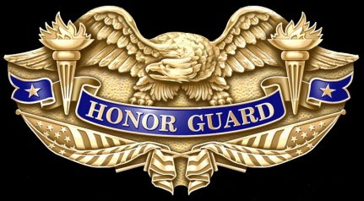

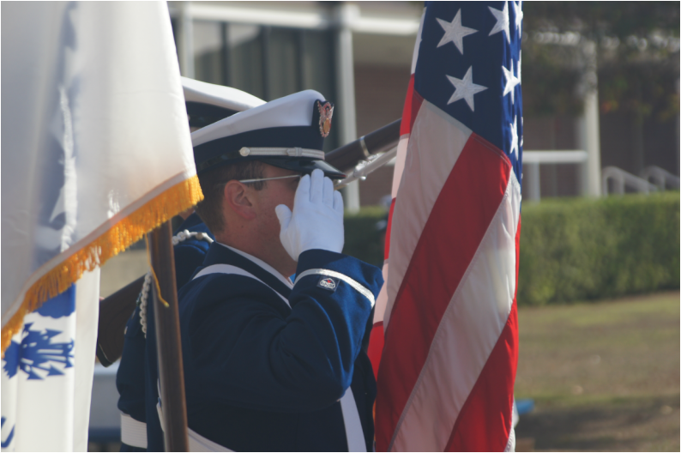

Notes:

