United States Coast Guard Auxiliary
District 11 Northern Region

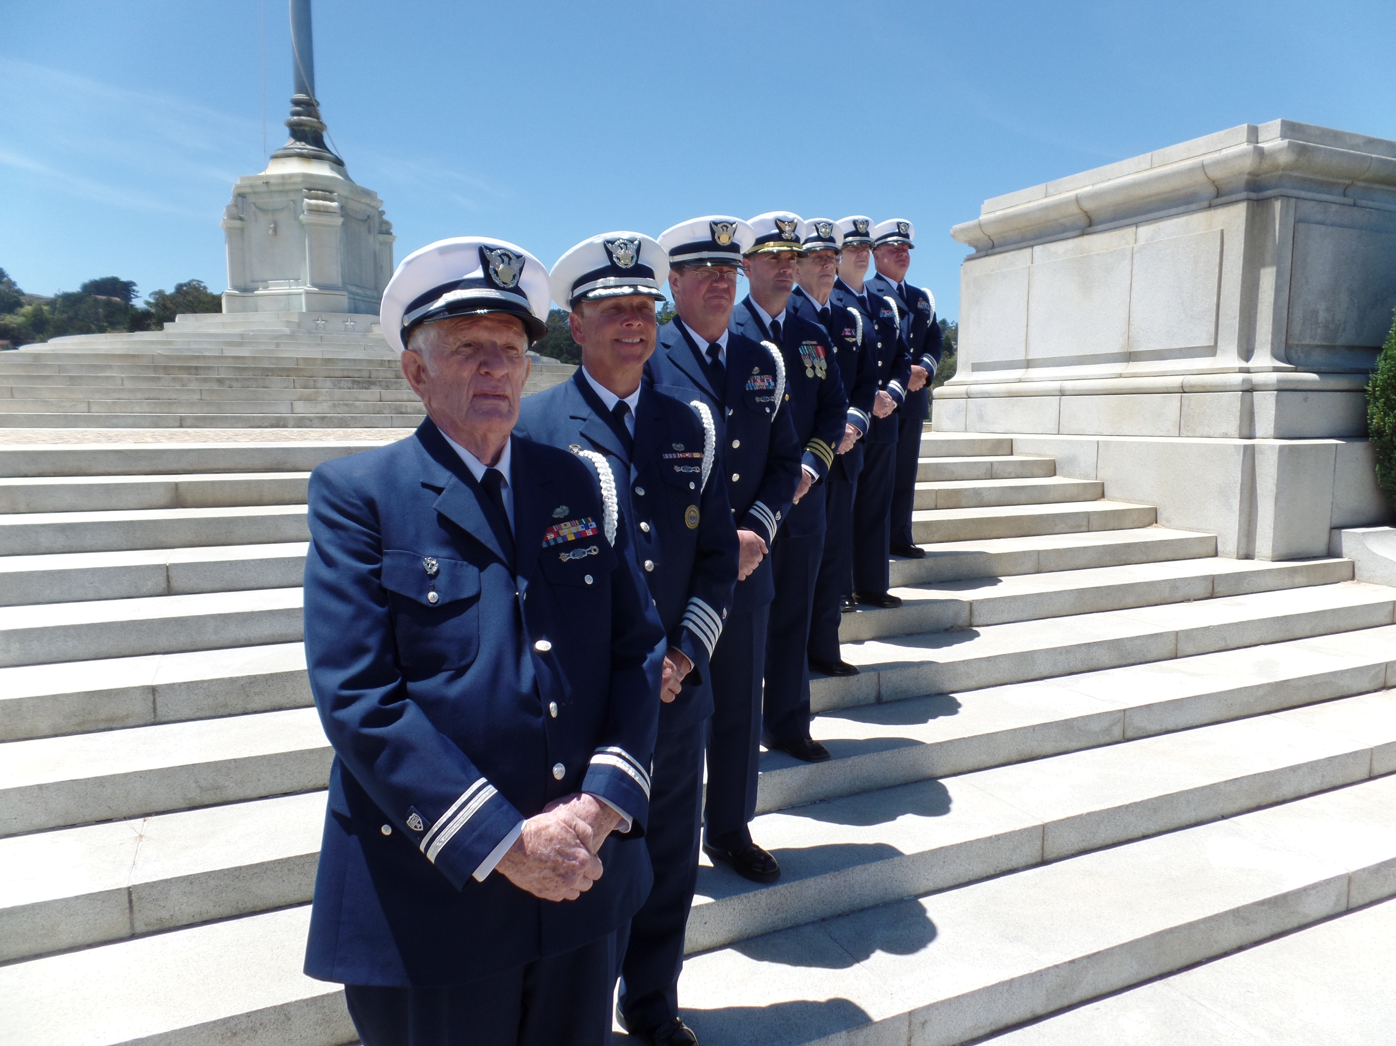

Ceremonial Honor Guard
Performance Qualification Standard

A: References

Subject: Untied States Coast Guard Auxiliary Honor Guard

  - Marine Corps Drill and Ceremonies Manual (Marine Corps Order P5060.20), COMDTINST M5060.11B
  - United States Flag Code, Title 4 of the United States Code
  - U.S. Coast Guard Auxiliary Manual, COMDTINST M16790.1F
  - U.S. Coast Guard Auxiliary Flags and Ceremony Guide
  - U.S. Coast Guard Auxiliary Memorial Guide Book
  - United States Coast Guard Ceremonial Honor Guard Website http://www.uscg.mil/honorguard/

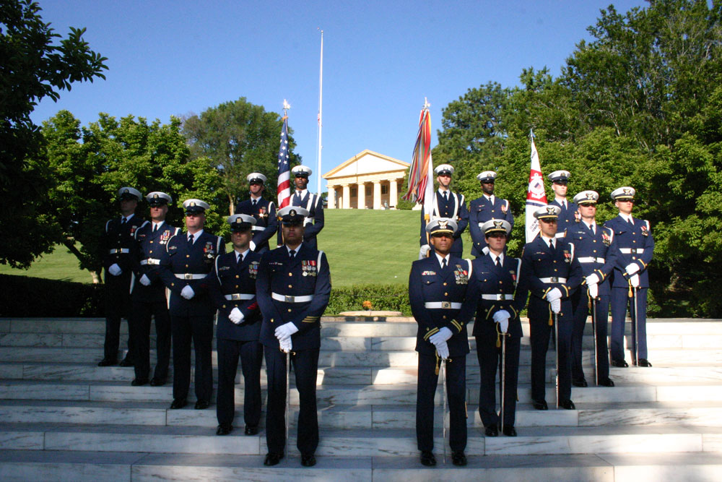

B. Requirements

- Personal Qualities: Must be stable, of excellent character and discretion, and unquestioned loyalty to the United States.
- Characteristics evaluated for selection: Maturity, self-control, objectivity, forthrightness, sincerity, attitude toward the service, others and themselves, cooperation and motivation.
- Must not have visible tattoos and adhere to the grooming standards of the Auxiliary Manual.
- No beards or mustaches are permitted; the face must be clean shaven at all times.
- Flotilla Commander or Honor Guard Recommendation
(Items the FC or HG will take into consideration when recommending an applicant will be if the person is in good standing within the flotilla, attends meetings regularly, wears the USCGAUX uniform properly for meetings, is physically capable of honor guard demands, cooperates in a team setting and has military bearing.)
- Applicant must be in BQ status unless applying in an approved joint venture status.
- Pass the 50 question exam with a score of 85% or better.
- Attend training sessions regularly. Typically 75% of sessions.
- By the ninth training session, the applicant must have secured and be prepared to display the required uniform items necessary to be a participant of the honor guard. The Captain of the Honor Guard will identify the necessary items and approximate costs. Items typically will be purchased at the applicants own expense. Typical required items: Service Dress Blue Uniform, Combination cap, White Dress Shirt, White Military Police Belt, Nickel Buckle, Blue Uniform Tie, White Glove and Dress Shoe Cordovan.
- Demonstrate basic drill marching/military maneuvers. To include but not limited to: Saluting, Position of Attention, Forward March, Facing Movements, etc.
- Adhere to all guidelines of the United States Coast Guard Auxiliary Ceremonial Honor Guard.
- Do nothing to disgrace yourself, your shipmates, the United States Coast Guard, the Coast Guard Auxiliary or the United States of America.
- Members may not be in a non-PQS qualified status for more than 18 months since the outset of attending their first meeting.
- Final decision of acceptance into the honor guard rests with the Captain of the Honor Guard/QE.
- Participate in a formal “going-up” ceremony.
- Serve with Pride, Poise, Devotion and Honor
- Strive for Perfection, Respect and Excellence
- Upon completion of the above, the member will be presented a White Ceremonial Shoulder Cord.

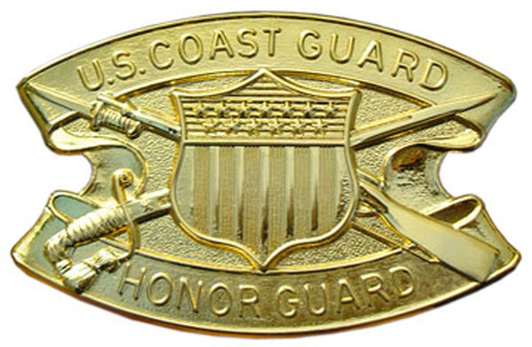

United States Coast Guard Auxiliary
District Eleven Northern Region
Ceremonial Honor Guard

C. Organizational Chart

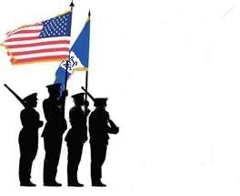

DIRAUX Commander
DIRAUX OTO
District Commodore
District Chief of Staff
District Public Affairs Officer, DSO-PA

Honor Guard Captain/Operations and Logistics Officer
(Duties: Coordinate training, QE for PQS, assign honor guard positions for ceremonies)

Honor Guard Chief/Training Officer
(Duties: Supervise training, recommend honor guard members/positions for ceremonies)

Assistant District Staff Officer, Public Affairs, Ceremonial Honor Guard, ADSO-PA/CHG
(Duties: Coordinate and direct honor guard activities.)

Honor Guard Supply Officer
(Duties: Maintain unit equipment/have available for ceremonies)

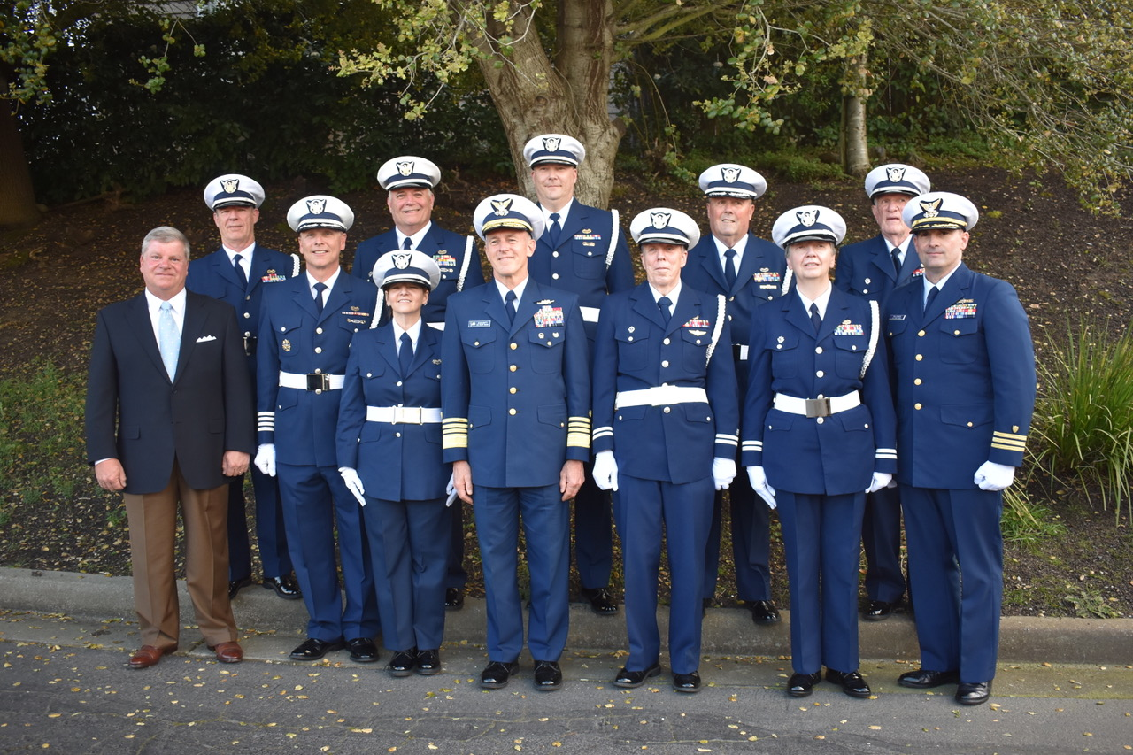

D. Creed

United States Coast Guard Auxiliary Honor Guard Creed
I am an Honor Guardsman and this is my Creed.
I will stand with Pride beside my Coast Guard Family.
I will maintain Poise at all times.
I will strive for Perfection.
I will Honor all who have served our country honorably.
I will Respect the Honor Guard Mission.
I will render Devotion unto this sacred duty.
By wearing this cord and device, I am committed to Excellence as a way of life.

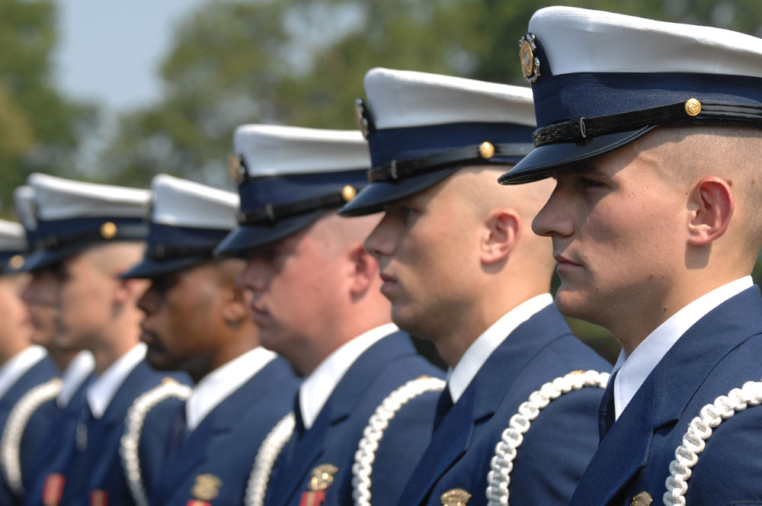

Honor Guard
Performance Qualification Standard

E. Introduction

This standard establishes the policies, protocols and procedures for training, qualification and certification of Auxiliary members for honor guard duty.
An honor guard is a ceremonial unit, often associated with the military, fire or police departments and composed of volunteers who are carefully screened for their loyalty, skills and commitment to service. Only those persons who are highly motivated and maintain exceptionally high standards of appearance and conduct and show aptitude for ceremonial duty are likely to be considered.
A primary role for honor guards in the United States and some other countries is to provide funeral honors for fallen comrades and to guard national monuments. An honor guard may also serve as the "guardians of the colors" by displaying and escorting the national flag on ceremonial occasions at various functions. In the Coast Guard family this may include Change of Watches, District Training events, retirements, dedications, banquets, memorial ceremonies, sporting events, recognition ceremonies, etc. Honor guards may serve as ambassadors to the public, presenting a positive image of their service, and assisting with the recruiting effort. The Auxiliary Honor Guard represents the Auxiliary and the United States Coast Guard in the highest of manners to the public.
The qualification of Auxiliary Honor Guard members must be linked to standards where excellence and selective measures are used to ensure the highest caliber of members. Honor Guard members may then be qualified and certified with assurance that they have been trained to expected minimum standards and voluntarily commit to the honor guard code/creed.

This standardized level of qualification will allow increased interoperability with Coast Guard units and be a true task force multiplier. The qualification detailed in this Standard is not related to the AUXOP program, but rather is an entirely new qualification program within the Public Affairs (PA) Department of the Auxiliary. Honor Guard individuals currently eligible are encouraged, but not required to meet the qualification detailed in this Standard. After the effective date of this Standard, completion of the qualification detailed in this Standard is required for all new honor guard members

F. Tasking Levels for Coast Guard Auxiliary Honor Guard

1. National United States Coast Guard Ceremonial Team Participation
2. Base Honor Guard Augmentation
3. Station Augmentation
4. National Events
5. District Events
6. Division Events
7. Flotilla Events
8. Community Events

Events to include all activities that a typical honor guard would participate in and would bring honor to the United States, the United States Coast Guard and the United States Coast Guard Auxiliary. Events would include and not be limited to the following: Funerals, presentation and securing of the colors, speeches, memorials, training events, memorials, changes of watch, dedications, banquets, recognition ceremonies, parades, scouting functions, sea cadet activities, etc.

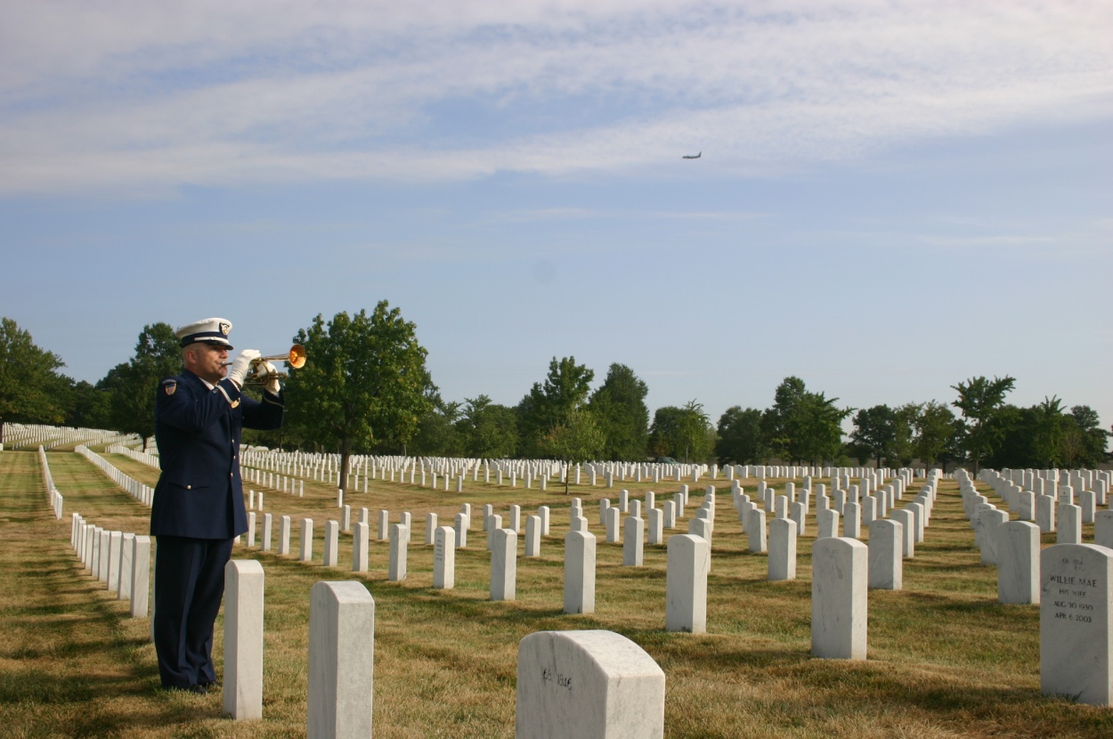

United States Coast Guard Auxiliary
Ceremonial Honor Guard
Personal Qualification Standards

A. Introduction

The Honor Guard Qualification Standards Guide is designed to be an integral part of the qualification process. It contains a collection of tasks that must be learned, practiced, and performed by the candidate. In addition, it contains a set of reading and practical assignments that provide policy and background information for the tasks.

1. Description of Tasks

2. Task designation

3. Task Identification
Tasks are identified by designation. For example: HGQ-1-1-1
a. (HGQ) - Volume designation – Honor Guard Qualification
b. (01) - Task Group designation number
c. (02) - Task order designation number
d. (HGQ) – Task Qualification number

4. Task – The knowledge or skill objective to be performed.

5. Reference - Information sources used by the trainee and instructor to obtain the background necessary for task performance.

6. Conditions - The environmental and physical circumstances in which the tasks must be performed. Any tools or special equipment needed for the completion of the task are listed here. The conditions listed with each task must be met

7. Standards – The specific outcome of the task. Successful task completion is a function of how well a student is able to complete the task without assistance.
a. Trainees must be able to cite, from memory, specific information and procedures.
b. Instructors (mentors) may wish to ask questions concerning particular steps for accomplishment in order to evaluate the trainee's total comprehension of the subject matter.
c. Trainees must be able to perform all performance tasks without prompting or assistance from the instructor. Each task demonstration must follow the correct sequence with little or no hesitation between the steps for accomplishment.

8. Performance Criteria - These steps delineate the procedure that is best followed for performing each task. They can be utilized two basic ways.
Some steps for task accomplishment follow exact procedures that are required for performing a particular operation or using a specific piece of equipment, while others serve as general
guidelines for task completion. They provide a performance check-off that can be used by the mentor to determine trainee performance when the trainee performs the task.

9. Accomplished – On the Mentor Tracking Form (Appendix G) the designated instructor (mentor) must print his/her name, sign and date this line attesting that the trainee successfully performed the task in accordance with the prescribed standards.

10. Comments - The comment section can be used to describe circumstances or conditions that might have a bearing on task completion. Failure to perform any element or unsatisfactory performance of an individual element should be noted in the comments section for the task. If the task is completed under more arduous circumstances than those described, a notation should be made.

B. Steps in the Qualification and Certification Process

1. Assignment to the training program - The trainee initiates entry into the qualification program by meeting the requirements as noted in this requirements section of this standard and then contacting the Flotilla Commander (FC) who will then endorse their participation or give guidance as to what requirements must still be met prior to contacting the honor guard captain with his recommendation.

2. Assignment of Mentor – Once a member meets all requirements and is accepted into the program a mentor is assigned by the Honor Guard Captain as the trainee’s primary instructor.

3. Completion of qualification guide - The trainee completes the qualification guide. To accomplish this, he/she follows the procedure below.

a) Step Procedure
1) Trainee selects a task.
2) Trainee completes reading assignment.
3) Task is demonstrated to trainee by the mentor.
4) Trainee practices the task.
5) Trainee demonstrates proficiency at least to the task standard.
6) Task is signed off by the mentor or other qualified honor guard member.
7) When all tasks for the desired level of certification are completed, the honor guard Captain and Honor Guard Chief reviews the completed task list, and test the candidate in an oral and practical demonstration of skills selected from among each task group. The candidate then participates in a “going-up” ceremony at an agreed upon time and place. The “going-up” ceremony is the culmination of basic training and the candidate’s final exam process. Formal uniform may be required. Upon successful completion of the “going-up” ceremony the candidate is accepted into the honor guard unit.

4. Certification - Upon successful completion of all tasks and successful demonstration in the “going-up” ceremony, the trainee will submit the signed-off task list to the Honor Guard Captain for approval and submission to the ADSO for Public Affairs (ADSO-PA) for verification submission to DIRAUX for certification.

5. Time Frame - Trainees shall complete all elements of the PQS within eighteen months from initial tasking sign-off. Should the PQS not be completed within eighteen consecutive months, the trainee will be removed from the program. Trainees so removed may reapply.

Personal Qualification Standard 1
Honor Guard (HG)
A. Honor Guard (HG) Duties
Honor Guard members may be assigned to duty at any identified tasking according to schedules arranged with the Honor Guard Captain, the Order Issuing Authority (OIA), district public affairs officer (DSO-PA), other elected district officers or a United States Coast Guard representative. Honor Guard members will follow all protocols and courtesies expected of an honor guardsman and discharge their duties in an honorable and respectful fashion. They will act in a dignified manner so as to bring honor to the United States, the United States Coast Guard and the United States Coast Guard Auxiliary. Honor Guard members will adhere to all guidelines within the U.S. Coast Guard Auxiliary Manual Honor Guard members are directly responsible for fulfilling duties of the missions they are assigned and for coordinating activities with the OIA or cognizant Coast Guard unit as needed.
The Honor Guard member must contact and coordinate with the Honor Guard Captain, OIA or cognizant CG unit in cases of distress, emergency or mishap.

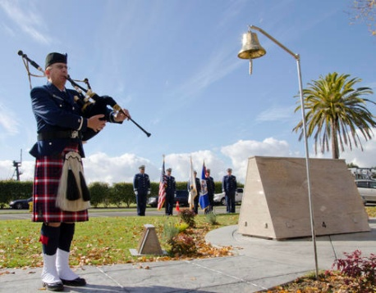

Trainee Name: _______________________________
EMPID_____________________________________

B. Tasks for Qualification
Task HGQ /1-9/01/HG
Task: Perform Basic Formation Skills
References: United States Marine Corps Drill and Ceremonies Manual
Conditions: Task must be performed in a group/team setting. Task must be done at a monthly training session. Defining formation terms will be done in a one on one setting.
Standards The trainee must perform basic formation skills without error and in coordination with the team with which they are performing.
Performance Criteria: Complete the basic skills as noted:

_____ Dress Left/Dress Right
_____ Dress Front/Dress Back
_____ Stand at Attention
_____ At Ease
_____ Parade Rest
_____ Fall In/Fall Out
_____ Be Prepared to Define Formation Terms: For Example; Column; Depth; Formation; etc

Sign-Off Member: ________________________
EMPID__________________________________

Task HGQ /1-9/02/HG
Task: Perform Basic Marching Skills
References: United States Marine Corps Drill and Ceremonies Manual
Conditions: Task must be performed in a group/team setting. Task must be done at a monthly training session.
Standards The trainee must perform basic marching skills without error and in coordination/step with the team with which they are performing.
Performance Criteria: Complete the basic skills as noted:

_____ Facing Movements
_____ Colors
_____ Color Wheel Turn
_____ Mark Time
_____ Walking in Rhythm
_____ Column Movements
_____ Step Off Marching
_____ Identify the Four Basic Commands and Show a Command Voice
_____ Identify Marching Terms: For example, Cadence, As You Were, etc.

Sign-Off Member: ________________________
EMPID__________________________________

Task HGQ /1-9/03/HG
Task: Perform Basic Manual of Arms Skills
References: United States Marine Corps Drill and Ceremonies Manual
Conditions: Task must be performed in a group/team setting. Task must be done at a monthly training session.
Standards The trainee must perform basic manual of arms skills without error and in coordination/sync with the team with which they are performing.
Performance Criteria: Complete the basic skills as noted:

_____ Order Arms
_____ Port Arms
_____ Present Arms
_____ Shoulder Arms
_____ Shoulder Arms with a Flag
_____ Port Arms with a Flag
_____ Demonstrate a Strong Grip on the Staff and a V Grip on the Staff

Sign-Off Member: ________________________
EMPID__________________________________

Task HGQ /1-9/04/HG
Task: Pass Uniform Inspection/Proper Wear
References: Auxiliary Manual/ http://www.uscg.mil/honorguard/, United States Coast Guard Uniform Manual. United States Coast Guard Uniform fitting and alteration Manual
Conditions: Task may be performed in a group/team setting or in a one to one meeting. Task must be done over a period of three monthly training sessions, one uniform per session.
Standards The trainee must properly wear the uniform/ribbons that has been chosen according to the Auxiliary Manual and/or the Honor Guard unit with which they are performing. The uniform needs to fit properly and present to the highest standards of the United States Coast Guard and the United States Coast Guard Auxiliary.
Performance Criteria: Complete the basic skills as noted:

_____ ODU—Proper fit, boots bloused, laces tucked, name tapes properly worn, no loose strands, cover properly worn, boots polished, etc.
_____ Service Dress Blue--Proper fit, ribbons/devices properly located on the ribbon rack and worn properly as measured by a ruler, name tag worn properly and straight, no loose strands, cover properly worn, shoes shined, clothes pressed, etc.
_____ Tropical Blue Uniform--Proper fit, ribbons/devices properly located on the ribbon rack and worn properly as measured by a ruler, name tag worn properly and straight, no loose strands, cover properly worn, shoes shined, clothes pressed, etc.
_____ Be able to answer questions regarding uniform wear according to the Auxiliary Manual

Sign-Off Member: ________________________
EMPID__________________________________

Task HGQ /1-9/05/HG
Task: Perform and Be Aware of Basic Military and Auxiliary Courtesies/Rank
References: Auxiliary Manual/ http://www.uscg.mil/honorguard/, Auxiliary Drill and Ceremonies Manual, United States Marine Corps Drill and Ceremonies Manual
Conditions: Task must be performed in a group/team setting. Task must be done at a monthly training session.
Standards The trainee must perform basic military and auxiliary courtesy awareness without error.
Performance Criteria: Complete the basic skills as noted:

_____ Execute a Proper Salute
_____ Execute a Slow Ceremonial Salute
_____ Identify the Ceremonial Salute Cadence
_____ Identify Basic Uniform Insignia
_____ Identify Basic Ribbon Placement

Sign-Off Member: ________________________
EMPID__________________________________

Task HGQ /1-9/06/HG
Task: Perform and Demonstrate Basic Funeral Responsibilities and Awareness
References: Auxiliary Manual/ http://www.uscg.mil/honorguard/, Auxiliary Drill and Ceremonies Manual, Auxiliary Memorial Guide Book
Conditions: Task must be performed in a group/team setting. Task must be done at a monthly training session.
Standards The trainee must perform basic funeral responsibilities and skills without error and in coordination with the team with which they are performing.
Performance Criteria: Complete the basic skills as noted:

_____ Two Man Flag fold
_____ Four Man Flag fold
_____ Placement of Flag on Casket
_____ Memorization of Primary Next of Kin (PNOK) Statement
_____ Proper triangular Flag Preparation
_____ Demonstrate proper burial at sea procedure

Sign-Off Member: ________________________
EMPID__________________________________

Task HGQ /1-9/07/HG
Task: Demonstrate the proper Hoisting, lowering and folding of National Ensign and additional colors
References: Auxiliary Manual/ http://www.uscg.mil/honorguard/, Auxiliary Drill and Ceremonies Manual, United States Marine Corps Drill and Ceremonies Manual
Conditions: Task must be performed in a group/team setting. Task must be done at a monthly training session.
Standards The trainee must perform basic military and auxiliary courtesy awareness without error.
Performance Criteria: Complete the basic skills as noted:

_____ Properly Hoist the morning colors
_____ Hoist the colors to half staff
_____ Properly retire the colors.

Sign-Off Member: ________________________
EMPID__________________________________

Task HGQ /1-9/08/HG
Task: Additional Tasks: Be familiar with at least three of the following protocols/duties.
References: Auxiliary Manual/ http://www.uscg.mil/honorguard/, Auxiliary Drill and Ceremonies Manual, United States Marine Corps Drill and Ceremonies Manual
Conditions: Task must be performed in a group/team setting. Task must be done at a monthly training session.
Standards The trainee must perform without error.
Performance Criteria: Complete the basic skills as noted:

_____ Rendering Honors for official Visits Ashore and Afloat.
_____ Side boys
_____ Quarterdeck sentry
_____ Fallen Comrades Table & Honors Ceremony
_____ Ringing of ships bells
_____ Sounding of Boatswain’s pipe
_____ Playing of Ceremonial Bugl

Sign-Off Member: ________________________
EMPID__________________________________

Task HGQ /1-9/09/HG
Task: Ceremony Set-up/Flag Etiquette/Going Up Ceremony
References: United States Marine Corps Drill and Ceremonies Manual, United States Flag Code, Auxiliary Manual, Auxiliary Honor Guard Requirements, Auxiliary Flags and Ceremony Guide, Auxiliary Drill and Ceremonies Manual, Auxiliary Memorial Guide Book,
http://www.uscg.mil/honorguard/
Conditions: Task must be performed in a group/team setting. Task must be done at a monthly training session. The trainee may perform the Going Up ceremony in a separate monthly session if requested. The ceremony set-up and flag etiquette portion may be done in ODUs. The Going Up ceremony must be done in the Service Dress Blue Uniform.
Standards The trainee must perform all expected ceremonial skills without error and in coordination with the team with which they are performing. The trainee must exhibit poise in the presentation.
Performance Criteria: Complete the basic skills as noted:

_____ Ceremony Set Up
_____ Team Coordination
_____ Leadership
_____ Flag placement
_____ Going Up Ceremony

Sign-Off Member: ________________________
EMPID__________________________________

APPENDIX A
Glossary

DEFINITIONS. The following definitions are standard terms used in the Standard

1. Alignment. The dressing of several elements on a straight line.
2. Assembly Area. A designated location for forming units of Unit size or larger in preparation for a parade, review or ceremony.
3. Arms. A term used to normally designate the service rifle but can refer to any weapon. When in formation and a mix of weapons is carried the term arms will be used to designate all types of weapons.
4. Base. The element on which a movement is regulated.
5. Cadence. A rhythmic rate of march at a uniform step.
6. Center. The middle element of a formation with an odd number of elements or the left center element of a formation with an even number of elements.
7. Ceremony. A formal military formation designated to observe a specific occasion.
8. Column. A formation in which elements are placed one behind the other. A section or Unit is in column when members of each squad are one behind the other with the squads abreast of each other.
9. Commander of Personnel (COP). The COP is the senior officer taking part in the ceremony. If an enlisted ceremony the COP is the senior enlisted.
10. Depth. The space from head to rear of an element or a formation. The depth of an individual is considered to be 12 inches.
11. Distance. The space between elements in the direction of depth. Between individuals, the space between your chest and the person to your front. Between vehicles, the space between the front end of a vehicle and the rear of the vehicle to its front. Between personnel in formation (either on foot, mounted, or in vehicles), the space from the front of the rear unit to the rear of the unit in front. Unit commanders, guides, and others whose positions in a formation are 40 inches from a rank are, themselves, considered a rank. Otherwise, commanders and those with them are not considered in measuring distance between units. The color guard is not considered in measuring distance between subdivisions of the unit with which it is posted. In Auxiliarist formations, the distance between ranks is 40 inches.
12. Double Time. Cadence at 180 steps (36 inches in length) per minute.
13. Element. An individual, squad, section, Unit, company, or other unit that is part of a larger unit.
14. Extended Mass Formation. The formation of a company or larger unit in which major elements are in column at close or normal interval and abreast at a specified interval greater than normal interval.
15. File. A single column of personnel or vehicles one behind the other.
16. Flank. The right or left extremity of a unit, either in line or in column. The element on the extreme right or left of the line. A direction at a right angle to the direction an element or a formation is facing.
17. Formation. Arrangement of elements of a unit in line, in column, or in any other prescribed manner.
18. Front. The space occupied by an element or a formation, measured from one flank to the other. The front of an individual is considered to be 22 inches.

19. Guide. The individual (base) upon whom a formation, or other elements thereof, regulates its march. To guide: to regulate interval, direction, or alignment; to regulate cadence on a base file (right, left, or center).
20. Head. The leading element of a column.
21. Interval. The lateral space between elements on the same line. Interval is measured between individuals from shoulder to shoulder and between vehicles from hub to hub or track to track. It is measured between elements other than individuals and between formations from flank to flank. Unit commanders and
those with them are not considered in measuring interval between elements of the unit. Normal interval between individuals is one arm's length. Close interval is the horizontal distance between shoulder and elbow when the left hand is placed on the left hip.
22. Left (Right). Extreme left (right) element or edge of a body of personnel.
23. Line. A formation in which the elements are side by side or abreast of each other. A section or Unit is in line when its squads are in line and one behind the other.
24. Line of March. The line on which individuals or units are to march on.
25. Line of Personnel. The line on which personnel are to form when in formation.
26. Loosened Sling. Indicates a sling adjusted for the movement sling arms.
27. Mass Formation. The formation of a company or larger unit in which the major elements are in column at close interval and abreast at close interval.
28. Muffling. The procedure of draping colors for mourning with a mourning streamer or black bunting. It also refers to the process of muffling the musical instruments of a band for specific types of ceremonies.
29. Pace. The length of a full step in quick time, 30 inches.
30. Parade. A parade is a ceremony that involves the movement of marching units.
31. Parade Sling. A sling that has all excess slack removed and is taught. The keeper is adjusted and locked in a position next to the sling tip. The sling liaison the left side of the rifle.
32. Piece. An individual firearm such as a rifle.
33. Point of Rest. The point toward which all elements of a unit establish their dress or alignment.
34. Quick Time. Cadence at 112 to 120 steps (12, 15, or 30 inches in length) per minute. It is the normal cadence for drills and ceremonies.
35. Rank. A line of personnel or vehicles placed side by side.
36. Review. A review is a type of ceremony that omits certain elements found in a parade, but includes an inspection (trooping the line) not found in a parade.
37. Rigged. This term refers to the condition when uniforms and equipment are properly fitted out in the manner for which they were intended for use. An Auxiliarist is rigged when wearing the prescribed uniform or equipment.
38. Slow Time. Cadence at 60 steps per minute. Used for funerals only.
39. Snap. In commands or signals, the quality that inspires immediate response. In drill the immediate and smart execution of a movement.
40. Step. The distance from heel to heel between the feet of a marching individual. The half step and back step are 15 inches. The right and left steps are 12 inches. The steps in quick and double time are 30 and 36 inches, respectively.
41. Strong Grip. The strong grip is when the thumb is wrapped around the front of the staff with the fingers wrapped to the rear.

42. Unit Leader. Is the individual who is drilling the unit. This can be any individual who is conducting drill or can be those assigned a specific billet such as squad leader, Unit sergeant, Unit commander, etc.
43. “V” Grip. The “V” grip is with the staff placed in the “V” formed by the thumbs and forefinger with the fingers extended and joined.

APPENDIX B
Mentor Tracking Form

Trainee’s Name:________________________ Member Number: ___________

Mentor/QE’s Name Printed | Mentor/QE’s Signature | Initials | Date:

Section 01
Perform Basic Formation Skills/Awareness
Task | Description | Mentor Signature | Date
HGQ /1-9/01/HG | Dress Left/Dress Right
 | Dress Front/Dress Back
 | Stand at Attention
 | At Ease
 | Parade Rest
 | Fall In/Fall Out
 | Be Prepared to Define Formation Terms: For Example; Column; Depth; Formation; etc.

Section 02
Perform Basic Marching Skills
Task | Description | Mentor Signature | Date
HGQ /1-9/02/HG | Facing Movements
 | Colors
 | Color Wheel Turn
 | Mark Time
 | Walking in Rhythm
 | Column Movements
 | Step Off Marching
 | Identify the Four Basic Commands and Show a Command Voice.
 | Identify Marching Terms: For example, Cadence, As You Were, etc.

Section 03
Perform Basic Manual of Arms Skills
Task | Description | Mentor Signature | Date
HGQ /1-9/03/HG | Order Arms
 | Port Arms
 | Present Arms
 | Shoulder Arms
 | Shoulder Arms with a Flag
 | Port Arms with a Flag
 | Demonstrate a Strong Grip on the Staff and a V Grip on the Staff

Section 04
Pass Uniform Inspection/Proper Wear
Task | Description | Mentor Signature | Date
HGQ /1-9/04/HG | ODU—Proper fit, boots bloused, laces tucked, name tapes properly worn, no loose strands, cover properly worn, boots polished, etc.
 | Service Dress Blue--Proper fit, ribbons/devices properly located on the ribbon rack and worn properly as measured by a ruler, name tag worn properly and straight, no loose strands, cover properly worn, shoes shined, clothes pressed, etc.
 | Tropical Blue Uniform--Proper fit, ribbons/devices properly located on the ribbon rack and worn properly as measured by a ruler, name tag worn properly and straight, no loose strands, cover properly worn, shoes shined, clothes pressed, etc.
 | Be able to answer questions regarding uniform wear according to the Auxiliary Manual

Section 05
Perform and Be Aware of Basic Military and Auxiliary Courtesies/Rank
Task | Description | Mentor Signature | Date
HGQ /1-9/05/HG | Execute a Proper Salute
 | Execute a Slow Ceremonial Salute
 | Identify the Ceremonial Salute Cadence
 | Identify Basic Uniform Insignia
 | Identify Basic Ribbon Placement

Section 06
Perform and Demonstrate Basic Funeral Responsibilities and Awareness
Task | Description | Mentor Signature | Date
HGQ /1-9/06/HG | Two Man Flag fold
 | Four Man Flag fold
 | Placement of Flag on Casket
 | Memorization of Primary Next of Kin (PNOK) Statement
 | Proper Triangular Flag Preparation

Section 07
Demonstrate the proper Hoisting, lowering and folding of the National Ensign and additional colors
Task | Description | Mentor Signature | Date
HGQ /1-9/07/HG | Properly Hoist the morning colors
 | Hoist the colors to half staff
 | Properly retire the colors

Section 08
Rendering Honors for official Visits Ashore and Afloat
Task | Description | Mentor Signature | Date
HGQ /1-9/08/HG | Side boys
 | Quarterdeck sentry
 | Fallen Comrades Table & Honors Ceremony
 | Ringing of ships bells
 | Sounding of Boatswain’s pipe
 | Playing of Ceremonial Bugle

Section 09
Ceremony Set-up/Flag Etiquette/Going Up Ceremony
Task | Description | Mentor Signature | Date
HGQ /1-9/09/HG | Ceremony Set Up
 | Team Coordination
 | Leadership
 | Flag Placement
 | Going Up Ceremony

Final Approval:

Approved and Forwarded to DSO-PA by: Honor Guard Captain

__________________________________________________ __________________________
Print Name Date

__________________________________________________ __________________________
Signature EMPID

Auxiliary District/Division/Flotilla _______/_______/_______
District 11 NR Honor Guard Captain

Approved and Forwarded to DIRAUX by:

__________________________________________________ __________________________
Print Name Date

__________________________________________________ __________________________
Signature EMPID

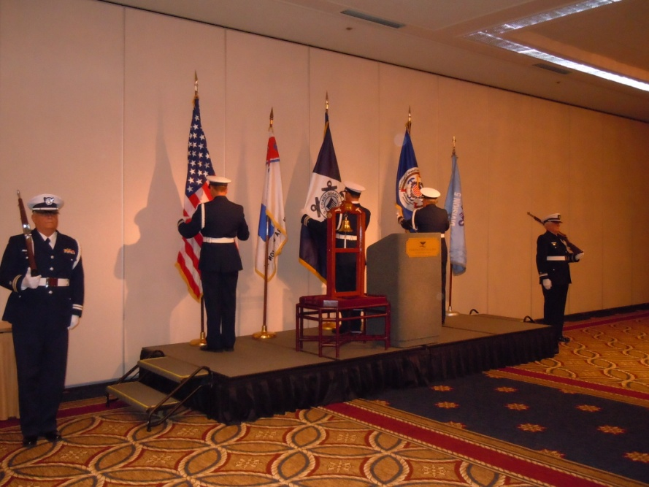

Notes:

